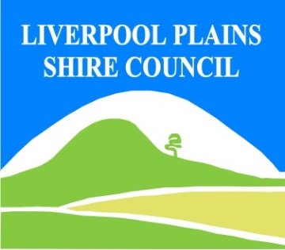
North West Regional Best Practice Guide for: Alligator Weed
Botanical Name: Alternanthera philoxeroides
Common Name: Alligator Weed
Priority Weeds Objective – Eradication (Whole of Region)
These weeds are present in limited distribution and abundance in the region. Elimination of the biosecurity risk posed by these weeds is a reasonably practical objective.

Alligator Weed: is a potentially devastating weed that grows in water and on land, affecting both waterways and floodplain areas. It is listed as a Weed of National Significance (WoNS). Alligator weed has extremely vigorous growth and great tolerance of normal control measures, which makes it a major threat to wetlands, rivers and irrigation systems. Alligator weed is considered one of the world's worst weeds because it impacts on both aquatic and terrestrial environments. Overseas experience indicates that its potential impacts in Australia could be devastating.

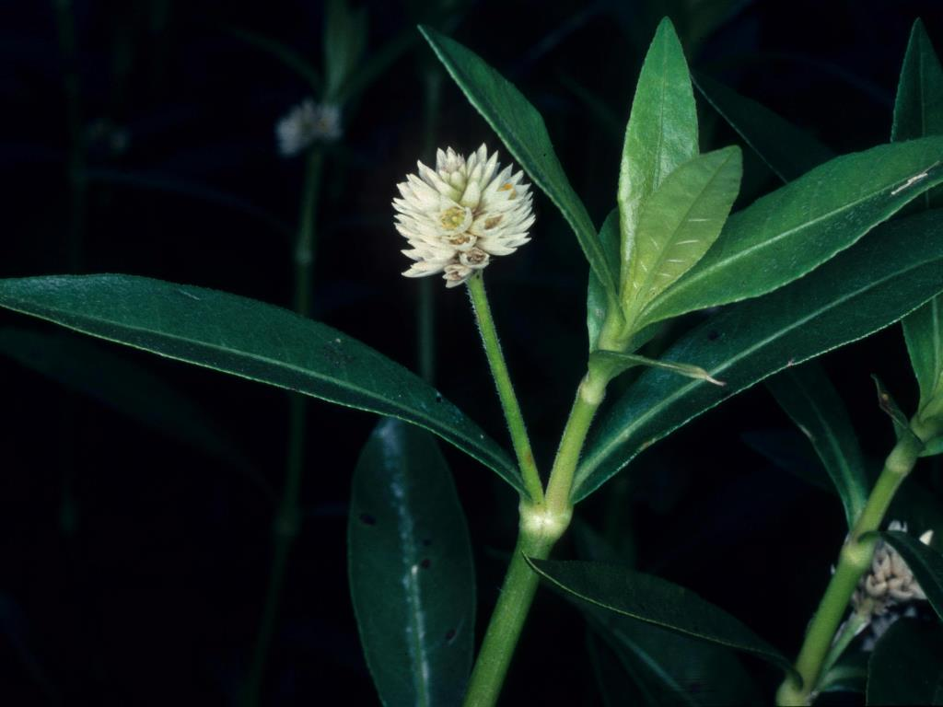
Photo: NSW DPI

General Biosecurity Duty – Biosecurity Act 2015
A general biosecurity duty applies to all dealings (as defined) with this species. Any person who deals with this species who knows (or ought to know) of any biosecurity risk posed by the plant, a carrier or a dealing , has a duty to ensure the biosecurity risk is prevented, eliminated or minimised, so far as is reasonably practicable.

Regional Recommended Measure:
Outcomes to demonstrate compliance with GBD
Whole Of region: Land managers should mitigate the risk of new weeds being introduced to their land. The plant or parts of the plant are not traded, carried, grown, carried or released into the environment
Biosecurity Regulation 2017- Part 5, Division 2 (Biosecurity Zone)
An owner or occupier of land in the Alligator weed biosecurity zone on which there is the weed Must (a) if the weed is part of a new infestation of the weed on the land, notify the local control authority for the land as soon as practical in accordance with Part6, and (b) eradicate the weed or if that is not practicable destroy as much of the weed as practicable and supress the spread of any remaining weed.
Mandatory Measure: A person must not import into the State or sell
Liverpool Plains Shire Local Control Requirements

Exclusion zone within LPSC
- The land is kept free of the plant, and
- Land managers will mitigate the risk of the plant being introduced to their land.

Penalty for not complying with the general biosecurity duty or a direction issued under the Biosecurity Act 2015
The maximum penalty is:
- in the case of an individual—$220,000 and, in the case of a continuing offence, a further penalty of $55,000 for each day the offence continues, or
- in the case of a corporation—$440,000 and, in the case of a continuing offence, a further penalty of $110,000 for each day the offence continues.
The maximum penalty for an offence that is committed negligently is:
- in the case of an individual—$1,100,000 and, in the case of a continuing offence, a further penalty of $137,500 for each day the offence continues, or
- in the case of a corporation—$2,200,000 and, in the case of a continuing offence, a further penalty of $275,000 for each day the offence continues.

Alligator Weed Control Calendar
JUNE | JULY | AUGUST | SEPT | OCT | NOV | DEC | JAN | FEB | MARCH | APRIL | MAY
GROWTH CYCLES-
 | GROWING SEASON
PROSTATE GROWTH |  |  | FLOWERING
INTERGRATED CONTROL TECHNIQUES AND ALTERNATIVES
HERBICIDE OPTIMUM
PHYSICAL REMOVAL-DEEP BURIAL
Registered Herbicide Application Rates:

Please refer to the NSW DPI Website NSW WeedWise. https://weeds.dpi.nsw.gov.au for current up to date permits and Registered Chemicals.
Or to NSW Weed Control Handbook 2018 7th Edition for Chemical Options.
.
Critical Comments:-
- Apply to actively growing plants.
- Consult your LCA Biosecurity Officer- Weeds for application tips.
- Always read and follow the Label instructions and SDS of respective herbicides.
NOTE:
- All Control Techniques involving herbicide use, must comply with the directions on the herbicide label or the conditions set out in a current permit to use a nominated herbicide.
- All chemical control programs must be carried out in accordance with the Pesticides Act 1999 and Pesticide Regulation 2017.
- All Chemical application programs used must be undertaken by or be designed and supervised by an appropriately Certified and Accredited Chemical user.
- Growth patterns and changes to optimum treatment times will vary with seasonal conditions due to rain events and air temperature changes, that may coincide with soil moisture availability.

Disclaimer:
This document has been prepared by the North West Regional Weed Committee and Local Government Control Authorities in good faith and on the basis of best available information. Users of this document must obtain their own specific advice and conduct their own investigations and assessments of their individual circumstances.

Linkage to Plans/Strategies  - North West Regional Strategic Weed Management Plan 2017-2022  - NSW Biosecurity Strategy 2013-2021  - NSW Biosecurity Act 2015  - NSW Invasive Species Plan 2018- 2021  - Pesticides Act 1999 and Pesticide Regulation 2017  References  - NSW DPI Website /WeedWise/ NSW Weed Control Handbook 2018 7th Edition. | For Further Information contact:  Liverpool Plains Shire Council’s  Authorised Officers (Weeds)  60 Station Street  Quirindi NSW 2343  PH: (02)67461755
Document Last Updated: 07-09-2021

