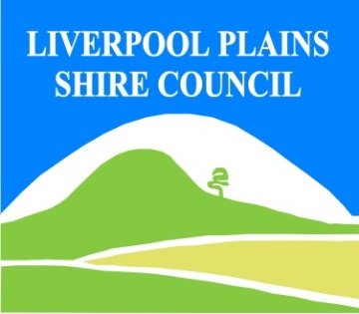
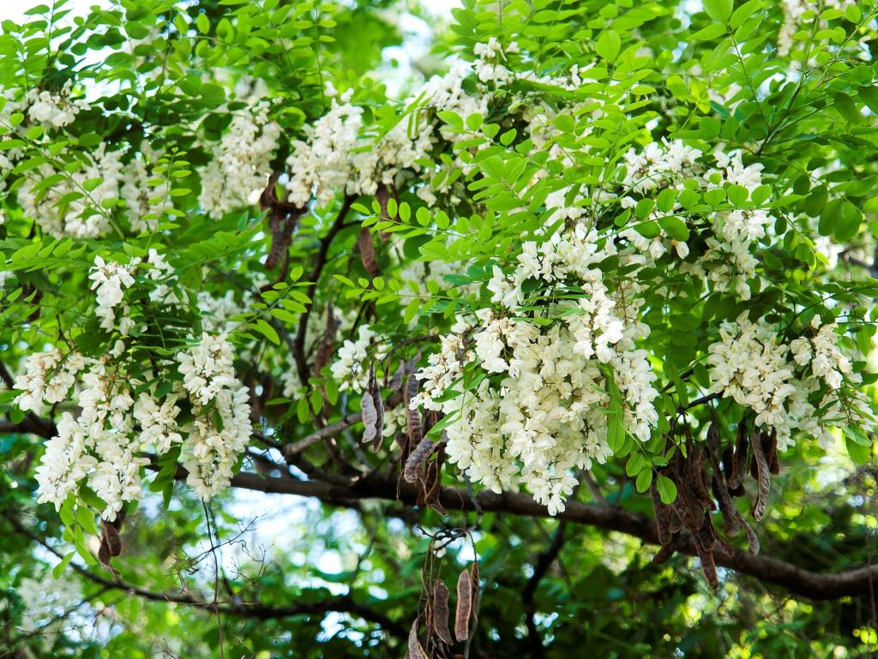
Photo: Courtesy DPI

Black Locust: Black Locust produces a large amount of root suckers to form quite dense thickets that exclude native vegetation. Black locust is toxic to humans and can cause discomfort and irritation, but is not life-threatening. All parts of the plant are poisonous, especially the pods, seeds, bark and leaves. It can cause dizziness, nausea, vomiting, diarrhoea, convulsions and drowsiness. Black Locust is a spiny deciduous tree to about 17 m high. Leaves are bright green, divided into leaflets with spines on stems. Pale flowers droop down in clusters. Seed pods are 3 – 8 cm long and reddish brown in colour.

North West Regional Best Practice Guide for: Black Locust
Botanical Name: Robinia pseudoacacia
Common Name: Black Locust
Priority Weeds Objective –Key Emerging: Prevent the establishment of new invasive species in the North West Local Land Services Region.

General Biosecurity Duty – Biosecurity Act 2015
A general biosecurity duty applies to all dealings (as defined) with this species. Any person who deals with this species who knows (or ought to know) of any biosecurity risk posed by the plant, a carrier or a dealing , has a duty to ensure the biosecurity risk is prevented, eliminated or minimised, so far as is reasonably practicable.

Liverpool Plains Shire Council Local Control Requirements

- Reduce the size and density of infested area by physical, mechanical and or chemical control methods, and
- Eliminate or minimise the risk of spread onto neighbouring lands.

Regional Recommended Measure
Outcomes to demonstrate compliance with GBD
Whole of Region:
Manage those identified as Key Emerging at the controllable level before they cross the threshold where control of spread is no longer an option.

Penalty for not complying with the general biosecurity duty or a direction issued under the Biosecurity Act 2015
The maximum penalty is:
- in the case of an individual—$220,000 and, in the case of a continuing offence, a further penalty of $55,000 for each day the offence continues, or
- in the case of a corporation—$440,000 and, in the case of a continuing offence, a further penalty of $110,000 for each day the offence continues.
The maximum penalty for an offence that is committed negligently is:
- in the case of an individual—$1,100,000 and, in the case of a continuing offence, a further penalty of $137,500 for each day the offence continues, or
- in the case of a corporation—$2,200,000 and, in the case of a continuing offence, a further penalty of $275,000 for each day the offence continues.

Black Locust Control Calendar
JAN | FEB | MARCH | APRIL | MAY | JUNE | JULY | AUG | SEPT | OCT | NOV | DEC
GROWTH CYCLES
FLOWERING
DORMANCY
PLANT SUCKERS FROM ROOT SYSTEM

INTERGRATED CONTROL TECHNIQUES AND ALTERNATIVES
BASAL BARK APPLICATION
MECHANICAL REMOVAL
Registered Herbicide Application Rates:
Please refer to the NSW DPI Website NSW WeedWise. https://weeds.dpi.nsw.gov.au for current up to date permits and Registered Chemicals.
Or to NSW Weed Control Handbook 2018 7th Edition for Chemical Options.

Critical Comments:
- Apply when plants are actively growing.
- Consult your LCA Biosecurity Officer- Weeds for application tips.
- Always read and follow the Label instructions and SDS of respective herbicides.
NOTE:
- All Control Techniques involving herbicide use, must comply with the directions on the herbicide label or the conditions set out in a current permit to use a nominated herbicide.
- All chemical control programs must be carried out in accordance with the Pesticides Act 1999 and Pesticide Regulation 2017.
- All Chemical application programs used must be undertaken by or be designed and supervised by an appropriately Certified and Accredited Chemical user.
- Growth patterns and the changes to optimum treatment times will vary with seasonal conditions due to air temperature changes that may coincide with soil and moisture availability.
Disclaimer:
This document has been prepared by the North West Regional Weed Committee and Local Government Control Authorities in good faith and on the basis of best available information. Users of this document must obtain their own advice and conduct their own investigations and assessments of their individual circumstances.

Triclopyr 240 g/L + Picloram 120 g/L (Access™ )
Rate: 1.0 L per 60 L of diesel
Comments: Foliar application. Triclopyr 240 g/L + Picloram 120 g/L (Access™ )
Rate: 1.0 L per 60 L of diesel
Comments: Foliar application.

Linkage to Plans/Strategies  - North West Regional Strategic Weed Management Plan 2017-2022  - NSW Biosecurity Strategy 2013-2021  - NSW Biosecurity Act 2015  - NSW Invasive Species Plan 2018- 2021  - Pesticides Act 1999 and Pesticide Regulation 2017  References  - NSW DPI Website /WeedWise/ NSW Weed Control Handbook 2018 7th Edition. | For Further Information contact:  Liverpool Plains Shire Council’s  Authorised Officers –Weeds.  60 Station Street  Quirindi NSW 2343  PH: (02)67461755
Document Last Updated: 07-09-2021

