Boxing Glove Cactus: Boxing glove cactus, native to south-western USA and northern Mexico, is occurring mainly in the drier regions of western New South Wales. It is regarded as an environmental weed, and can injure people and animals with its sharp thorns, reduce livestock access to pastures and displace native and other useful plant species. At present it is not common or widespread in NSW, but over the last few year’s populations have rapidly increased in density and area. It is now locally common in and around the mining settlements of Broken Hill, Cumborah, Grawin and Lightning Ridge. It is also spreading around Tibooburra in far western NSW.
North West Regional Best Practice Guide for: Boxing Glove Cactus
Botanical Name: Cylindropuntia fulgida var. mamillata)
Common Name: Boxing Glove Cactus, Coral cactus, Jumping cactus, Jumping cholla, Prickly pear
Priority Weeds Objective – Key Emerging: Prevent the establishment of new invasive species in the North West Local Land Services Region.

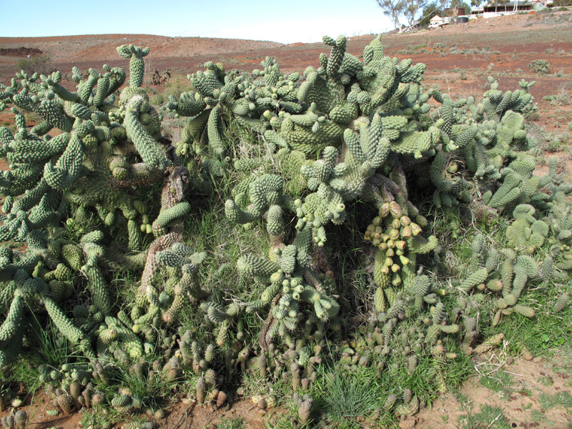
Photo: Bob Chinnock

General Biosecurity Duty – Biosecurity Act 2015
A general biosecurity duty applies to all dealings (as defined) with this species. Any person who deals with this species who knows (or ought to know) of any biosecurity risk posed by the plant, a carrier or a dealing , has a duty to ensure the biosecurity risk is prevented, eliminated or minimised, so far as is reasonably practicable.

Regional Recommended Measure
Outcomes to demonstrate compliance with GBD
Mandatory Measure (Division 8, Clause 33, Biosecurity Regulation 2017): A person must not import into the State or sell.
Manage those identified as Key Emerging at the controllable level before they cross the threshold where control of spread is no longer an option.

Liverpool Plains Shire Council Local Control Requirements

- Reduce the size and density of infested area by physical, mechanical and or chemical control methods, and
- Eliminate or minimise the risk of spread onto neighbouring lands

Penalty for not complying with the general biosecurity duty or a direction issued under the Biosecurity Act 2015
The maximum penalty is:
- in the case of an individual—$220,000 and, in the case of a continuing offence, a further penalty of $55,000 for each day the offence continues, or
- in the case of a corporation—$440,000 and, in the case of a continuing offence, a further penalty of $110,000 for each day the offence continues.
The maximum penalty for an offence that is committed negligently is:
- in the case of an individual—$1,100,000 and, in the case of a continuing offence, a further penalty of $137,500 for each day the offence continues, or
- in the case of a corporation—$2,200,000 and, in the case of a continuing offence, a further penalty of $275,000 for each day the offence continues.

Boxing Glove/ Coral Cactus Control Calendar
JAN | FEB | MARCH | APRIL | MAY | JUNE | JULY | AUG | SEPT | OCT | NOV | DEC
GROWTH CYCLES
SEEDS GERMINATE |  | SEEDS GERMINATE
SEGMENTS SET ROOTS ONTO BARE SOIL AFTER RAIN |  | SEGMENTS SET ROOTS ONTO BARE SOIL AFTER RAIN
FLOWER AND FRUIT SET |  | FLOWER AND FRUIT SET
ACTIVE GROWTH |  | ACTIVE GOWTH
INTERGRATED CONTROL TECHNIQUES AND ALTERNATIVES
PHYSICALLY REMOVE PLANTS AND DESTROY BY BURNING ANYTIME THROUGHOUT THE YEAR
HERBICIDE USE |  | HERBICIDE USE
 |  | RELEASE BIOAGENTS
FOLLOW UP ANY REGROWTH AS IT APPEARS AND DESTROY BY PHYSICAL REMOVAL OR SPRAY WITH HERBICIDES
Biological Control: A strain of cochineal (Dactylopius tomentosus), a native of Mexico, was recently released near Tibooburra and Stephens Creek north of Broken Hill. While only in the early stages of establishment, the cochineal is expected to control the cactus as other cochineals have controlled other cacti. Landholders with infestations of boxing glove cactus can contact DPI to organise a release of this new agent (biotype testing to establish correct identification of the cactus will be done as part of this process).
Registered Herbicide Application Rates:
Please refer to the NSW DPI Website NSW WeedWise. https://weeds.dpi.nsw.gov.au for current up to date permits and Registered Chemicals.
Or to NSW Weed Control Handbook 2018 7th Edition for Chemical Options.

Critical Comments:
- Apply when plants are actively growing.
- Consult your LCA Biosecurity Officer- Weeds for application tips.
- Always read and follow the Label instructions and SDS of respective herbicides.
NOTE:
- All Control Techniques involving herbicide use must comply with the directions on the herbicide label or the conditions set out in a current permit to use a nominated herbicide.
- All chemical control programs must be carried out in accordance with the Pesticides Act 1999 and Pesticide Regulation 2017.
- All Chemical application programs used must be undertaken by or be designed and supervised by an appropriately Certified and Accredited Chemical user.
- Growth patterns and the changes to optimum treatment times will vary with seasonal conditions due to air temperature changes that may coincide with soil and moisture availability.

Disclaimer: This document has been prepared by the North West Regional Weed Committee and Local Government Control Authorities in good faith and on the basis of best available information. Users of this document must obtain their own advice and conduct their own investigations and assessments of their individual circumstances.

Triclopyr 240 g/L + Picloram 120 g/L (Access™ )
Rate: 1.0 L per 60 L of diesel
Comments: Foliar application. Triclopyr 240 g/L + Picloram 120 g/L (Access™ )
Rate: 1.0 L per 60 L of diesel
Comments: Foliar application.

Linkage to Plans/Strategies  - North West Regional Strategic Weed Management Plan 2017-2022  - NSW Biosecurity Strategy 2013-2021  - NSW Biosecurity Act 2015  - NSW Invasive Species Plan 2018- 2021  - Pesticides Act 1999 and Pesticide Regulation 2017  References  - NSW DPI Website /WeedWise/ NSW Weed Control Handbook 2018 7th Edition.. | For Further Information contact:  Liverpool Plains Shire Council’s  Authorised Officers –Weeds.  60 Station Street  Quirindi NSW 2343  PH: (02)67461755
Document Last Updated: 07-09-2021

