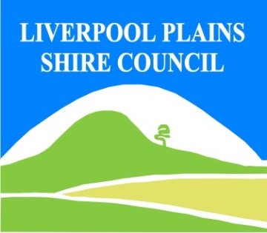
North West Regional Best Practice Guide for: Chilean Needle Grass
Botanical Name: Nassella neesiana
Common Name: Chilean Needle Grass
Priority Weeds Objective - Containment
These weeds are widely distributed in the region. While broad scale elimination is not practicable, minimisation of the biosecurity risk posed by this weed is reasonably practicable.

Chilean needle grass: is closely related to serrated tussock (Nassella trichotoma). Chilean needle grass affects both sown pasture and native grasslands of southeastern Australia. It is relatively unpalatable and reduces farm productivity by displacing more desirable pasture species. Heavy infestations can decrease productivity by as much as 50% during summer. It also causes injury to stock and downgrades wool, skins and hides with its long, sharp seeds.
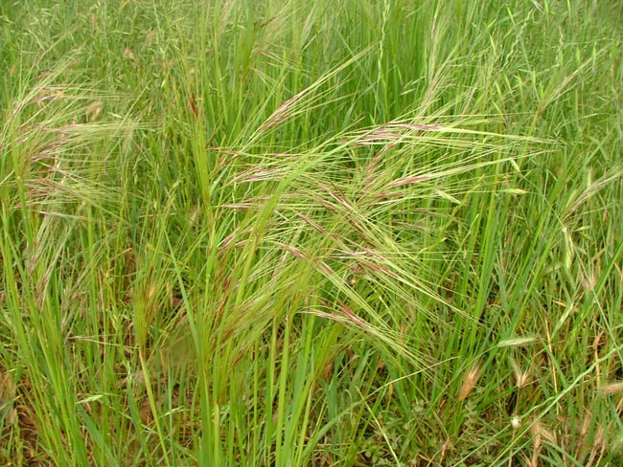
Photo: John Hoskings

General Biosecurity Duty – Biosecurity Act 2015
A general biosecurity duty applies to all dealings (as defined) with this species. Any person who deals with this species who knows (or ought to know) of any biosecurity risk posed by the plant, a carrier or a dealing , has a duty to ensure the biosecurity risk is prevented, eliminated or minimised, so far as is reasonably practicable.

Regional Recommended Measure: An exclusion zone is established for all lands in the region, except the core infestation area comprising the Tamworth Regional Council.
Outcomes to demonstrate compliance with GBD
Whole Of region: the plant or parts of the plant are not traded, carried, grown or released into the environment
Within Exclusion Zone: Land Managers should prevent spread from their land, Land Mangers mitigate the risk of the plant being introduced to their land.
Within Core Infestation: Land managers should reduce impacts from the plant on priority assets.
Mandatory measure: A person must not import into the State or sell.
Liverpool Plains Shire Local Control Requirements

Exclusion zone within LPSC
- The land is kept free of the plant, and
- Land managers will mitigate the risk of the plant being introduced to their land.

Penalty for not complying with the general biosecurity duty or a direction issued under the Biosecurity Act 2015
The maximum penalty is:
- in the case of an individual—$220,000 and, in the case of a continuing offence, a further penalty of $55,000 for each day the offence continues, or
- in the case of a corporation—$440,000 and, in the case of a continuing offence, a further penalty of $110,000 for each day the offence continues.
The maximum penalty for an offence that is committed negligently is:
- in the case of an individual—$1,100,000 and, in the case of a continuing offence, a further penalty of $137,500 for each day the offence continues, or
- in the case of a corporation—$2,200,000 and, in the case of a continuing offence, a further penalty of $275,000 for each day the offence continues.

Chilean Needle Grass Control Calendar
MARCH | APRIL | MAY | JUNE | JULY | AUG | SEPT | OCT | NOV | DEC | JAN | FEB
GROWTH CYCLES-
GERMINATION |  | GERMINATION
 |  |  | SEED HEADS EMERGE
 |  |  |  |  |  | SEED SHED
INTERGRATED CONTROL TECHNIQUES AND ALTERNATIVES
 | HIGH DENSITY-SHORT DURATION STRATEGIC GRAZING MANAGEMENT SYSTEM
PASTURE SOWING/  ESTABLISHMENT/MANAGEMENT |  |  |  | PASTURE SOWING/  ESTABLISHMENT/MANAGEMENT
 |  |  | HEAVY GRAZING MAY REDUCE FLOWERING & POTENTIAL SEED SET
Registered Herbicide Application Rates:
Please refer to the NSW DPI Website NSW WeedWise. https://weeds.dpi.nsw.gov.au for current up to date permits and Registered Chemicals.
Or to NSW Weed Control Handbook 2018 7th Edition for Chemical Options.

.Critical Comments:-
- Apply to actively growing plants.
- Consult your LCA Biosecurity Officer- Weeds for application tips.
- Always read and follow the Label instructions and SDS of respective herbicides.
NOTE:
- All Control Techniques involving herbicide use, must comply with the directions on the herbicide label or the conditions set out in a current permit to use a nominated herbicide.
- All chemical control programs must be carried out in accordance with the Pesticides Act 1999 and Pesticide Regulation 2017.
- All Chemical application programs used must be undertaken by or be designed and supervised by an appropriately Certified and Accredited Chemical user.
- Growth patterns and changes to optimum treatment times will vary with seasonal conditions due to rain events and air temperature changes, that may coincide with soil moisture availability.
Disclaimer:
This document has been prepared by the North West Regional Weed Committee and Local Government Control Authorities in good faith and on the basis of best available information. Users of this document must obtain their own specific advice and conduct their own investigations and assessments of their individual circumstances.

Linkage to Plans/Strategies  - North West Regional Strategic Weed Management Plan 2017-2022  - NSW Biosecurity Strategy 2013-2021  - NSW Biosecurity Act 2015  - NSW Invasive Species Plan 2018- 2021  - Pesticides Act 1999 and Pesticide Regulation 2017  References  - NSW DPI Website /WeedWise/ NSW Weed Control Handbook 2018 7th Edition. | For Further Information contact:  Liverpool Plains Shire Council’s  Authorised Officers (Weeds)  60 Station Street  Quirindi NSW 2343  PH: (02)67461755
Document Last Updated: 07-09-2021

