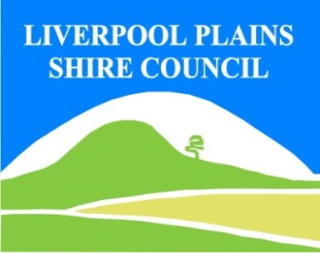
Water Lettuce is a free floating aquatic plant native to Asia, Africa and equatorial America. It was believed to have been introduced as an aquarium and water garden plant sold in nurseries. Under favourable conditions water lettuce will produce abundant growth that can expand rapidly and form an obstructive mat that can interfere with irrigation, boating and water sport activities. These mats can have negative impacts on native aquatic plants and animals, and harbour disease causing mosquitoes. It can reproduce vegetatively as well as from seed.
North West Regional Best Practice Guide for: Water Lettuce
Botanical Name: Pistia Stratiotes
Common Names: Water Lettuce, Nile Cabbage, Water Lily
North West Regional Priority Weeds Objective: Eradication (Whole of Region). Water Lettuce is present in limited distribution and abundance in the region. Elimination of the biosecurity risk posed by it is a reasonably practicable objective.

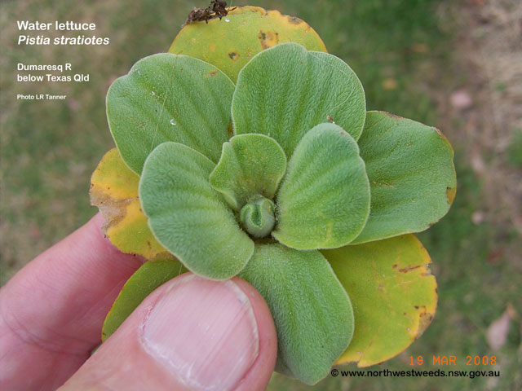
Photo: Les Tanner, North West Weeds

General Biosecurity Duty – Biosecurity Act 2015
A general biosecurity duty applies to all dealings (as defined) with this species. Any person who deals with this species who knows (or ought to know) of any biosecurity risk posed by the plant, a carrier or a dealing , has a duty to ensure the biosecurity risk is prevented, eliminated or minimised, so far as is reasonably practicable.

Liverpool Plains Shire Local Control Requirements
- The land is kept free of the plant, and
- Land managers will mitigate the risk of the plant being introduced to their land
- Notify Local Control Authority if found
Regional Recommended Measure
Outcomes to demonstrate compliance with GBD
- The plant or parts of the plant are not traded, carried, grown or released into the environment
- The plant is eradicated from the land and the land is kept free of the plant.
- Land managers should mitigate the risk of new weeds being introduced to their land.
- The plant should not be bought, sold grown, carried or released into the environment.
- Notify Local Control Authority if found.

Penalty for not complying with the general biosecurity duty or a direction issued under the Biosecurity Act 2015
The maximum penalty is:
- in the case of an individual—$220,000 and, in the case of a continuing offence, a further penalty of $55,000 for each day the offence continues, or
- in the case of a corporation—$440,000 and, in the case of a continuing offence, a further penalty of $110,000 for each day the offence continues.
The maximum penalty for an offence that is committed negligently is:
- in the case of an individual—$1,100,000 and, in the case of a continuing offence, a further penalty of $137,500 for each day the offence continues, or
- in the case of a corporation—$2,200,000 and, in the case of a continuing offence, a further penalty of $275,000 for each day the offence continues.

Water Lettuce Control Calendar
JAN | FEB | MARCH | APRIL | MAY | JUNE | JULY | AUG | SEPT | OCT | NOV | DEC
GROWTH C
 |  | FLOWERING & SEEDING
ACTIVE GROWTH |  | ACTIVE GOWTH
INTERGRATED CONTROL TECHNIQUES AND ALTERNATIVES
PHYSICALLY REMOVE PLANTS AND DESTROY BY BURNING ANYTIME THROUGHOUT THE YEAR
OPTIMUM HERBICIDE USE |  | OPTIMUM HERBICIDE USE
Registered Herbicide Application Rates:
Please refer to the NSW DPI Website NSW WeedWise. https://weeds.dpi.nsw.gov.au for current up to date permits and Registered Chemicals.
Or to NSW Weed Control Handbook 2018 7th Edition for Chemical Options.
Critical Comments:
- Apply when plants are actively growing.
- Consult your LCA Biosecurity Officer- Weeds for application tips.
- Always read and follow the Label instructions and SDS of respective herbicides.

NOTE:
- All Control Techniques involving herbicide use, must comply with the directions on the herbicide label or the conditions set out in a current permit to use a nominated herbicide.
- All chemical control programs must be carried out in accordance with the Pesticides Act 1999 and Pesticide Regulation 2017.
- All Chemical application programs used must be undertaken by or be designed and supervised by an appropriately Certified and Accredited Chemical user.
- Growth patterns and the changes to optimum treatment times will vary with seasonal conditions due to air temperature changes that may coincide with soil and moisture availability.

Disclaimer:
This document has been prepared by the North West Regional Weed Committee and Local Government Control Authorities in good faith and on the basis of best available information. Users of this document must obtain their own advice and conduct their own investigations and assessments of their individual circumstances.

Linkage to Plans/Strategies  - North West Regional Strategic Weed Management Plan 2017-2022  - NSW Biosecurity Strategy 2013-2021  - NSW Biosecurity Act 2015  - NSW Invasive Species Plan 2018- 2021  - Pesticides Act 1999 and Pesticide Regulation 2017  References  - NSW DPI Website /WeedWise/ NSW Weed Control Handbook 2018 7th Edition. | For Further Information contact:  Liverpool Plains Shire Council’s  Authorised Officers –Weeds.  60 Station Street  Quirindi NSW 2343  PH: (02)67461755
Document Last Updated: 07-09-2021

