North West Regional Best Practice Guide for: Rope Pear
Botanical Name: Cylindropuntia imbricata
Common Name: Devil’s Rope Pear, Rope Pear
Priority Weeds Objective – Asset Protection
These weeds are widely distributed in the region. Their spread should be minimised to protect priority assets.

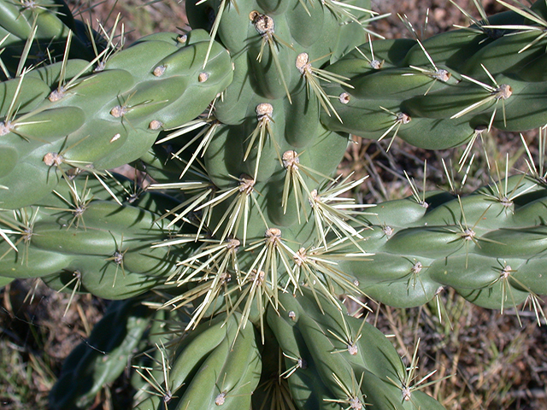
Photo: John Hosking

Rope Pear: Is native to the USA and central Mexico and first recorded in Australia in 1911. Rope pear is a very spiny cactus which can cause injury to humans and animals. It has the ability to form impenetrable clumps and reduce stock carrying capacity. Segments break off easily and can spread to new sites via flood waters. It’s very hardy, grows readily and requires very little moisture.

General Biosecurity Duty – Biosecurity Act 2015
A general biosecurity duty applies to all dealings (as defined) with this species. Any person who deals with this species who knows (or ought to know) of any biosecurity risk posed by the plant, a carrier or a dealing , has a duty to ensure the biosecurity risk is prevented, eliminated or minimised, so far as is reasonably practicable.

Liverpool Plains Shire Local Control Requirements

- Reduce the size and density of infested area by physical, mechanical and or chemical control methods, and
- Eliminate or minimise the risk of spread onto neighbouring lands.

Regional Recommended Measure
Outcomes to demonstrate compliance with GBD
- Land Managers should prevent seed and propagules spreading from their land.
- Land managers should mitigate the risk of new weeds being introduced to their land.
- Land managers reduce the impacts of the plant on priority assets.
Mandatory Measure (Division 8, Clause 33 Biosecurity Regulation 2017)- A person must not import into the State or sell.

Penalty for not complying with the general biosecurity duty or a direction issued under the Biosecurity Act 2015
The maximum penalty is:
- in the case of an individual—$220,000 and, in the case of a continuing offence, a further penalty of $55,000 for each day the offence continues, or
- in the case of a corporation—$440,000 and, in the case of a continuing offence, a further penalty of $110,000 for each day the offence continues.
The maximum penalty for an offence that is committed negligently is:
- in the case of an individual—$1,100,000 and, in the case of a continuing offence, a further penalty of $137,500 for each day the offence continues, or
- in the case of a corporation—$2,200,000 and, in the case of a continuing offence, a further penalty of $275,000 for each day the offence continues.

Rope Pear Control Calendar
JAN | FEB | MARCH | APRIL | MAY | JUNE | JULY | AUG | SEPT | OCT | NOV | DEC
GROWTH CYCLES
SEEDS GERMINATE |  | SEEDS GERMINATE
SEGMENTS SET ROOTS ONTO BARE SOIL AFTER RAIN |  | SEGMENTS SET ROOTS ONTO BARE SOIL AFTER RAIN
 |  |  | FLOWER AND FRUIT SET
ACTIVE GROWTH |  | ACTIVE GOWTH
INTERGRATED CONTROL TECHNIQUES AND ALTERNATIVES
 | PHYSICALALLY REMOVE PLANTS AND DESTROY BY BURNING ANYTIME THROUGHOUT THE YEAR
 |  | OPTIMUM HERBICIDE USE |  | OPTIMUM HERBICIDE USE
 |  |  |  |  |  | RELEASE BIOAGENTS FOLLOWUP HERBICIDES IN AUTUMN
FOLLOW UP ANY REGROWTH AS IT APPEARS AND DESTROY BY PHYSICAL REMOVAL OR SPRAY WITH HERBICIDES
Registered Herbicide Application Rates:
Please refer to the NSW DPI Website NSW WeedWise. https://weeds.dpi.nsw.gov.au for current up to date permits and Registered Chemicals.
Or to NSW Weed Control Handbook 2018 7th Edition for Chemical Options.
Critical Comments:
- Apply when plants are actively growing.
- Consult your weeds officer for application tips
- Always read and follow the Label instructions and SDS of respective herbicides.
NOTE:
- All Control Techniques involving herbicide use must comply with the directions on the herbicide label or the conditions set out in a current permit to use the nominated herbicide.
- All chemical control programs must be carried out in accordance with the Pesticides Act 1999 and Pesticide Regulation 2017.
- All Chemical application programs used must be undertaken by or be designed and supervised by an appropriately Certified and Accredited Chemical user.
Growth patterns and the changes to optimum treatment times will vary with seasonal conditions due to air temperature changes that may coincide with soil and moisture availability.
Disclaimer:
This document has been prepared by the North West Regional Weed Committee and Local Government Control Authorities in good faith and on the basis of best available information. Users of this document must obtain their own advice and conduct their own investigations and assessments of their individual circumstances.
Linkage to Plans/Strategies  - North West Regional Strategic Weed Management Plan 2017-2022  - NSW Biosecurity Strategy 2013-2021  - NSW Biosecurity Act 2015  - NSW Invasive Species Plan 2018- 2021  - Pesticides Act 1999 and Pesticide Regulation 2017  References  - NSW DPI Website /WeedWise/ NSW Weed Control Handbook 2018 7th Edition. |  |  |  |  | For Further Information:  Liverpool Plains Shire Council’s  Authorised Officers (Weeds)  60 Station Street  Quirindi NSW 2343  PH: (02)67461755
Document Last Updated: 07-09-2021

