North West Regional Best Practice Guide for: Galenia
Botanical Name: Galenia pubescens
Common Name: Galenia (coastal galenia, carpet weed)
Priority Weeds Objective - Key Emerging: Prevent the establishment of new invasive species in the North West Local Land Services Region.

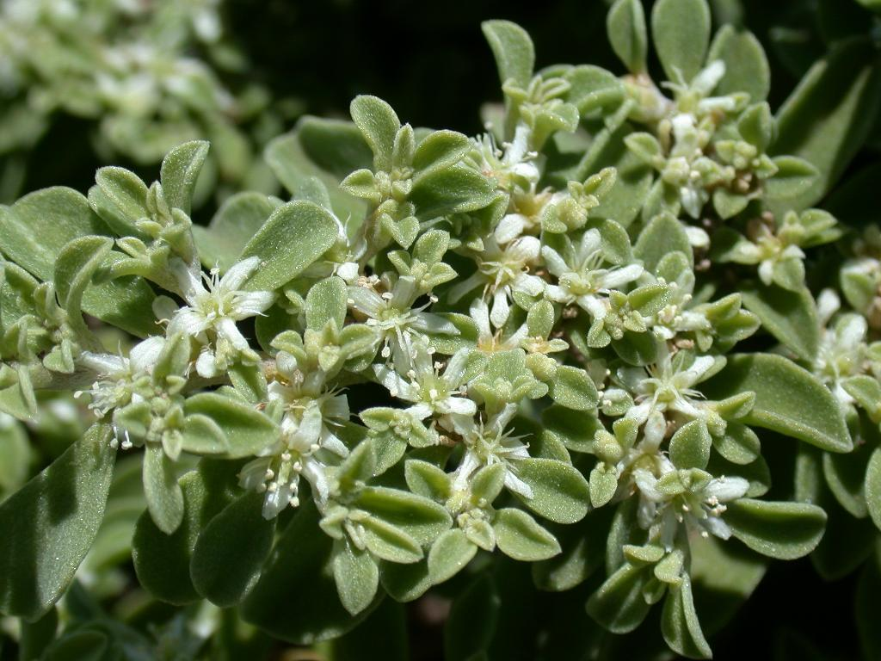
Photo: John Hoskings

Photo: John Hoskings

Galenia: Drought and salt tolerant, Galenia grows over and smothers existing vegetation by forming a thick dense mat. It invades coastal dunes, pastures, disturbed areas, lawns, roadsides and rocky outcrop vegetation. Galenia is known to produce nitrates that can be toxic to Stock. Bees that collect the nectar of Galenia produce honey with such a disagreeable flavour that is unsaleable. Native to South Africa. It has now naturalised in the USA, Spain and Chile. Galenia is scattered throughout many sites in NSW, Victoria, South Australia and Western Australia. It is of particular concern through the Hunter Valley and Liverpool Plains regions of NSW.

General Biosecurity Duty – Biosecurity Act 2015
A general biosecurity duty applies to all dealings (as defined) with this species. Any person who deals with this species who knows (or ought to know) of any biosecurity risk posed by the plant, a carrier or a dealing , has a duty to ensure the biosecurity risk is prevented, eliminated or minimised, so far as is reasonably practicable.

Liverpool Plains Shire Council Local Control Requirements

- Reduce the size and density of infested area by physical, mechanical and or chemical control methods, and
- Eliminate or minimise the risk of spread onto neighbouring lands.

Regional Recommended Measure:
Outcomes to demonstrate compliance with GBD

Manage those identified as Key Emerging at the controllable level before they cross the threshold where control of spread is no longer an option.

Penalty for not complying with the general biosecurity duty or a direction issued under the Biosecurity Act 2015
The maximum penalty is:
- in the case of an individual—$220,000 and, in the case of a continuing offence, a further penalty of $55,000 for each day the offence continues, or
- in the case of a corporation—$440,000 and, in the case of a continuing offence, a further penalty of $110,000 for each day the offence continues.
The maximum penalty for an offence that is committed negligently is:
- in the case of an individual—$1,100,000 and, in the case of a continuing offence, a further penalty of $137,500 for each day the offence continues, or
- in the case of a corporation—$2,200,000 and, in the case of a continuing offence, a further penalty of $275,000 for each day the offence continues.

Galenia Control Calendar

MARCH | APRIL | MAY | JUNE | JULY | AUG | SEPT | OCT | NOV | DEC | JAN | FEB
GROWTH CYCLES-
GERMINATION |  | GERMINATION
 |  |  | FLOWERS and SEED SET
INTERGRATED CONTROL TECHNIQUES AND ALTERNATIVES
 | MECHANICAL REMOVAL-Burn large perennial plants
HERBICIDE APPLICATION |  |  | HERBICIDE APPLICATION
Registered Herbicide Application Rates:
Please refer to the NSW DPI Website NSW WeedWise. https://weeds.dpi.nsw.gov.au for current up to date permits and Registered Chemicals.
Or to NSW Weed Control Handbook 2018 7th Edition for Chemical Options.

Critical Comments:
- Apply to actively growing plants.
- Consult your LCA Biosecurity Officer- Weeds for application tips.
- Always read and follow the Label instructions and SDS of respective herbicides.
NOTE:
- All Control Techniques involving herbicide use, must comply with the directions on the herbicide label or the conditions set out in a current permit to use a nominated herbicide.
- All chemical control programs must be carried out in accordance with the Pesticides Act 1999 and Pesticide Regulation 2017.
- All Chemical application programs used must be undertaken by or be designed and supervised by an appropriately Certified and Accredited Chemical user.
- Growth patterns and changes to optimum treatment times will vary with seasonal conditions due to rain events and air temperature changes, that may coincide with soil moisture availability.
Disclaimer:
This document has been prepared by the North West Regional Weed Committee and Local Government Control Authorities in good faith and on the basis of best available information. Users of this document must obtain their own specific advice and conduct their own investigations and assessments of their individual circumstances.

Linkage to Plans/Strategies  - North West Regional Strategic Weed Management Plan 2017-2022  - NSW Biosecurity Strategy 2013-2021  - NSW Biosecurity Act 2015  - NSW Invasive Species Plan 2018- 2021  - Pesticides Act 1999 and Pesticide Regulation 2017  References  - NSW DPI Website /Weedwise/ NSW Weed Control Handbook 2018 7th Edition. | For Further Information contact:  Liverpool Plains Shire Council’s  Authorised Officers –Weeds.  60 Station Street  Quirindi NSW 2343  PH: (02)67461755
Document Last Updated: 07-09-2021

