North West Regional Best Practice Guide for: Harrisia Cactus
Botanical Name: Harrisia martini and H. tortuosa
Common Name: Harrisia Cactus
Priority Weeds Objective – Containment
These weeds are widely distributed in the region. While broad scale elimination is not practicable, minimisation of the biosecurity risk posed by these weeds is reasonably practicable.

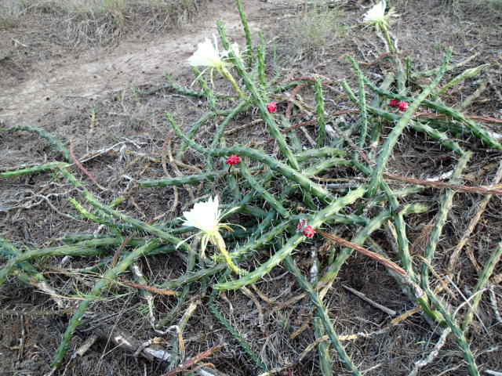
Photo: Ian Schwartz

Harrisia Cactus: Is native to the Americas which was introduced to Australia as a garden plant. It has now become a serious problem in parts of Queensland and New South Wales. Harrisia Cactus is spread by seed. The plant can begin to produce seed by six months of age and from then on can continue to produce fruit all year round. The sharp spines are a hazard to humans and animals and it is hard to control because of its seed producing ability.

General Biosecurity Duty – Biosecurity Act 2015
A general biosecurity duty applies to all dealings (as defined) with this species. Any person who deals with this species who knows (or ought to know) of any biosecurity risk posed by the plant, a carrier or a dealing, has a duty to ensure the biosecurity risk is prevented, eliminated or minimised, so far as is reasonably practicable.

Liverpool Plains Shire Council Local Control Requirements

Exclusion zone within Region
- The land is kept free of the plant, and
- Land managers will mitigate the risk of the plant being introduced to their land.

Regional Recommended Measure
Outcomes to demonstrate compliance with GBD
An Exclusion Zone is established for all lands in the region, except the core infestation area comprising the Gwydir Shire Council and the Moree Plains Shire Council.
Whole of Region: The plant or parts of the plant are not traded, carried, grown or released into the environment.
Within Exclusion zone: The plant is eradicated from the land and the land is kept free of the plant. Land managers mitigate the risk of the plant being introduced to their land.
Within Core infestation: Land managers should reduce impacts from the plant on priority assets.
Mandatory Measure - A person must not import into the State or sell.

Penalty for not complying with the general biosecurity duty or a direction issued under the Biosecurity Act 2015
The maximum penalty is:
- in the case of an individual—$220,000 and, in the case of a continuing offence, a further penalty of $55,000 for each day the offence continues, or
- in the case of a corporation—$440,000 and, in the case of a continuing offence, a further penalty of $110,000 for each day the offence continues.
The maximum penalty for an offence that is committed negligently is:
- in the case of an individual—$1,100,000 and, in the case of a continuing offence, a further penalty of $137,500 for each day the offence continues, or
- in the case of a corporation—$2,200,000 and, in the case of a continuing offence, a further penalty of $275,000 for each day the offence continues.

Harrisia Cactus Control Calendar
JAN | FEB | MARCH | APRIL | MAY | JUNE | JULY | AUG | SEPT | OCT | NOV | DEC
GROWTH CYCLES
SEEDS GERMINATE |  | SEEDS GERMINATE
SEGMENTS SET ROOTS ONTO BARE SOIL AFTER RAIN |  | SEGMENTS SET ROOTS ONTO BARE SOIL AFTER RAIN
FLOWER AND FRUIT SET |  | FLOWER AND FRUIT SET
ACTIVE GROWTH |  | ACTIVE GOWTH
INTERGRATED CONTROL TECHNIQUES AND ALTERNATIVES
PHYSICALLY REMOVE PLANTS AND DESTROY BY BURNING ANYTIME THROUGHOUT THE YEAR
HERBICIDE USE
RELEASE BIOAGENTS
FOLLOW UP ANY REGROWTH AS IT APPEARS AND DESTROY BY PHYSICAL REMOVAL OR SPRAY WITH HERBICIDES
Biological Control: A mealybug (Hypogeococcus festerianus) is established on Harrisia Cactus in NSW and provides a significant level of control.
Registered Herbicide Application Rates:
Please refer to the NSW DPI Website NSW WeedWise. https://weeds.dpi.nsw.gov.au for current up to date permits and Registered Chemicals.
Or to NSW Weed Control Handbook 2018 7th Edition for Chemical Options.

Critical Comments:
- Apply when plants are actively growing.
- Consult your LCA Biosecurity Officer- Weeds for application tips
- Always read and follow the Label instructions and SDS of respective herbicides.
NOTE:
- All Control Techniques involving herbicide use, must comply with the directions on the herbicide label or the conditions set out in a current permit to use a nominated herbicide.
- All chemical control programs must be carried out in accordance with the Pesticides Act 1999 and Pesticide Regulation 2017.
- All Chemical application programs used must be undertaken by or be designed and supervised by an appropriately Certified and Accredited Chemical user.
- Growth patterns and the changes to optimum treatment times will vary with seasonal conditions due to air temperature changes that may coincide with soil and moisture availability.
Disclaimer:
This document has been prepared by the North West Regional Weed Committee and Local Government Control Authorities in good faith and on the basis of best available information. Users of this document must obtain their own advice and conduct their own investigations and assessments of their individual circumstances.

Triclopyr 240 g/L + Picloram 120 g/L (Access™ )
Rate: 1.0 L per 60 L of diesel
Comments: Foliar application. Triclopyr 240 g/L + Picloram 120 g/L (Access™ )
Rate: 1.0 L per 60 L of diesel
Comments: Foliar application.

Linkage to Plans/Strategies  - North West Regional Strategic Weed Management Plan 2017-2022  - NSW Biosecurity Strategy 2013-2021  - NSW Biosecurity Act 2015  - NSW Invasive Species Plan 2018- 2021  - Pesticides Act 1999 and Pesticide Regulation 2017  References  - NSW DPI Website /WeedWise/ NSW Weed Control Handbook 7th Edition. | For Further Information contact:  Liverpool Plains Shire Council’s  Authorised Officers –Weeds.  60 Station Street  Quirindi NSW 2343  PH: (02)67461755
Document Last Updated: 07-09-2021

