+
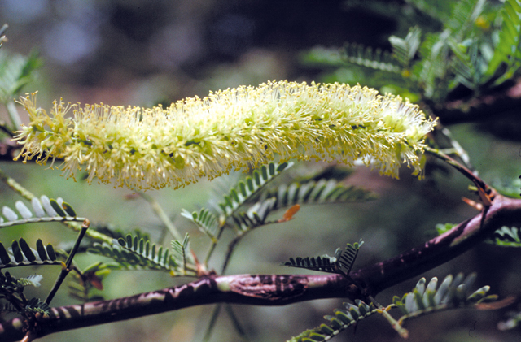
Photo: Colin G Wilson

Mesquite: A woody weed that invades open grasslands, rangelands and the banks of watercourses, forming thick, impenetrable, thorny thickets. Mesquite has a long lifecycle, very high seed production, the ability to survive droughts and long seed dormancy. Mesquite is native to the America’s. It has become an invasive weed in many parts of the world. Originally planted as a fodder, shade and ornamental trees. It has now spread throughout Australia. In New South Wales (NSW), infestations of mesquite have mostly occurred throughout the Broken Hill and Milparinka areas, with isolated plants found in the south-western Riverina district and in the north-western areas of Gilgandra, Coonamble and Bourke. Mesquite has the potential to invade all areas of western NSW.

North West Regional Best Practice Guide for: Mesquite
Botanical Name: Mesquite (Prosopis species)
Common Names: Mesquite
State Priority Weeds Objective – CONTAINMENT: These weeds are widely distributed in the region. While broad scale elimination is not practicable, minimisation of the biosecurity risk posed by these weeds is reasonably practicable.

General Biosecurity Duty – Biosecurity Act 2015
All plants are regulated with a general biosecurity duty to prevent, eliminate or minimise any biosecurity risk they may pose. Any person who deals with any plant, who knows (or ought to know) of any biosecurity risk, has a duty to ensure the risk is prevented, eliminated or minimised, so far as is reasonably practicable.

Liverpool Plains Shire Council Local Control Requirements

Exclusion Zone in the Region
- The land is kept free of the plant, and
- Land managers will mitigate the risk of the plant being introduced to their land.

Regional Recommended Measure:
An exclusion zone is established for all lands in the region, except the core infestation area comprising lands within the Walgett Shire Council.
Outcomes to demonstrate compliance with GBD
Whole Of region: the plant or parts of the plant are not traded, carried, grown or released into the environment
Within Exclusion Zone: The plant is eradicated from the land and the land is kept free of the plant. Land Managers should prevent spread from their land. Land Managers should mitigate the risk of the plant being introduced to their land
Within Core Infestation: Land managers should reduce impacts from the plant on priority assets.
Mandatory Measure (Division 8, Clause 33, Biosecurity Regulation 2017): A person must not import into the State or sell.

Penalty for not complying with the general biosecurity duty or a direction issued under the Biosecurity Act 2015
The maximum penalty is:
- in the case of an individual—$220,000 and, in the case of a continuing offence, a further penalty of $55,000 for each day the offence continues, or
- in the case of a corporation—$440,000 and, in the case of a continuing offence, a further penalty of $110,000 for each day the offence continues.
The maximum penalty for an offence that is committed negligently is:
- in the case of an individual—$1,100,000 and, in the case of a continuing offence, a further penalty of $137,500 for each day the offence continues, or
- in the case of a corporation—$2,200,000 and, in the case of a continuing offence, a further penalty of $275,000 for each day the offence continues.

Mesquite Control Calendar
JAN | FEB | MARCH | APRIL | MAY | JUNE | JULY | AUG | SEPT | OCT | NOV | DEC
GROWTH CYCLES
 |  | FLOWERS AND SEED SET
 |  | SEEDS GERMINATE
ACTIVE GROWTH |  | ACTIVE GOWTH
INTERGRATED CONTROL TECHNIQUES AND ALTERNATIVES
PHYSICALLY REMOVE PLANTS AND DESTROY BY BURNING ANYTIME THROUGHOUT THE YEAR
OPTIMUM HERBICIDE USE |  | OPTIMUM HERBICIDE USE
Registered Herbicide Application Rates:
Please refer to the NSW DPI Website NSW WeedWise. https://weeds.dpi.nsw.gov.au for current up to date permits and Registered Chemicals.
Or to NSW Weed Control Handbook 2018 7th Edition for Chemical Options.

Critical Comments:
- Apply when plants are actively growing.
- Consult your LCA Biosecurity Officer- Weeds for application tips
- Always read and follow the Label instructions and SDS of respective herbicides.
NOTE:
- All Control Techniques involving herbicide use, must comply with the directions on the herbicide label or the conditions set out in a current permit to use a nominated herbicide.
- All chemical control programs must be carried out in accordance with the Pesticides Act 1999 and Pesticide Regulation 2017.
- All Chemical application programs used must be undertaken by or be designed and supervised by an appropriately Certified and Accredited Chemical user.
- Growth patterns and the changes to optimum treatment times will vary with seasonal conditions due to air temperature changes that may coincide with soil and moisture availability.

Disclaimer:
This document has been prepared by the North West Regional Weed Committee and Local Government Control Authorities in good faith and on the basis of best available information. Users of this document must obtain their own advice and conduct their own investigations and assessments of their individual circumstances.

Linkage to Plans/Strategies  - North West Regional Strategic Weed management Plan 2017-2022  - NSW Biosecurity Strategy 2013-2021  - NSW Biosecurity Act 2015  - Pesticides Act 1999 and Pesticide Regulation 2017  References  - NSW DPI Website /WeedWise/ NSW Weed Control Handbook 2018 7th Edition. | For Further Information contact:  Liverpool Plains Shire Council’s  Authorised Officers –Weeds.  60 Station Street  Quirindi NSW 2343  PH: (02)67461755
Document Last Updated: 07-09-2021

