North West Regional Best Practice Guide for: Parkinsonia
Botanical Name: Parkinsonia aculeata
Common Names: Parkinsonia, Jerusalem Thorn
State Priority Weeds Objective –Control Order -Eradication, Whole of state
Parkinsonia is present in limited distribution and abundance in some parts of the state. Elimination of the biosecurity risk posed by this weed is a reasonably practical objective.

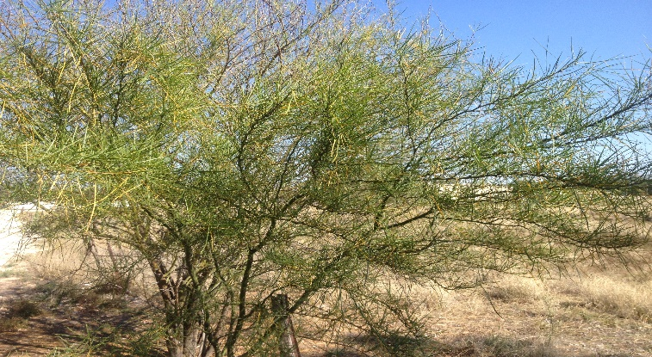
Photo: Ian Schwartz

Parkinsonia is a thorny native of Central America, southern USA, Mexico, the Caribbean and the north of South America. It was introduced into Australia in the late 1800’s as a shade and ornamental tree, with the largest infestations being in QLD, NT and northern WA. In NSW isolated infestations have been found in Broken Hill, Walgett, Bourke and Mungindi. Parkinsonia is a weed of National Significance.

General Biosecurity Duty – Biosecurity Act 2015
A general biosecurity duty applies to all dealings (as defined) with this species. Any person who deals with this species who knows (or ought to know) of any biosecurity risk posed by the plant, a carrier or a dealing , has a duty to ensure the biosecurity risk is prevented, eliminated or minimised, so far as is reasonably practicable.

Liverpool Plains Shire Local Control Requirements
Exclusion zone within LPSC
- The land is kept free of the plant, and
- Land managers will mitigate the risk of the plant being introduced to their land.
- Notify the Local Control Authority for the area if the Parkinsonia is part of a new infestation on the land as soon as practicable after becoming aware of the new infestation.
- Immediately destroy all Parkinsonia on the land, ensure that subsequent generations of parkinsonian are destroyed and the land is kept free of Parkinsonia.

Regional Recommended Measure
Outcomes to demonstrate compliance with GBD
Control Order
Parkinsonia Control Zone (Whole of NSW):
Owners and occupiers of land on which there is parkinsonia must notify the local control authority of new infestations; immediately destroy the plants; ensure subsequent generations are destroyed; and ensure the land is kept free of the plant. A person who deals with a carrier of parkinsonia must ensure the plant (and any seed and propagules) is not moved from the land; and immediately notify the local control authority of the presence of the plant.

Penalty for not complying with the general biosecurity duty or a direction issued under the Biosecurity Act 2015
The maximum penalty is:
- in the case of an individual—$220,000 and, in the case of a continuing offence, a further penalty of $55,000 for each day the offence continues, or
- in the case of a corporation—$440,000 and, in the case of a continuing offence, a further penalty of $110,000 for each day the offence continues.
The maximum penalty for an offence that is committed negligently is:
- in the case of an individual—$1,100,000 and, in the case of a continuing offence, a further penalty of $137,500 for each day the offence continues, or
- in the case of a corporation—$2,200,000 and, in the case of a continuing offence, a further penalty of $275,000 for each day the offence continues.

Parkinsonia Control Calendar
JAN | FEB | MARCH | APRIL | MAY | JUNE | JULY | AUG | SEPT | OCT | NOV | DEC
GROWTH CYCLES
SEEDS GERMINATE
FLOWER AND POD SET |  |  |  | FLOWER AND POD SET
ACTIVE GROWTH |  |  |  | ACTIVE GOWTH
INTERGRATED CONTROL TECHNIQUES AND ALTERNATIVES
PHYSICALLY REMOVE PLANTS AND DESTROY BY BURNING ANYTIME THROUGHOUT THE YEAR
OPTIMUM HERBICIDE USE |  | OPTIMUM HERBICIDE USE
Registered Herbicide Application Rates:
Please refer to the NSW DPI Website NSW WeedWise. https://weeds.dpi.nsw.gov.au for current up to date permits and Registered Chemicals.
Or to NSW Weed Control Handbook 2018 7th Edition for Chemical Options.
Critical Comments:
- Apply when plants are actively growing.
- Consult your LCA Biosecurity Officer- Weeds for application tips
- Always read and follow the Label instructions and SDS of respective herbicides.
NOTE:
- All Control Techniques involving herbicide use, must comply with the directions on the herbicide label or the conditions set out in a current permit to use a nominated herbicide.
- All chemical control programs must be carried out in accordance with the Pesticides Act 1999 and Pesticide Regulation 2017.
- All Chemical application programs used must be undertaken by or be designed and supervised by an appropriately Certified and Accredited Chemical user.
- Growth patterns and the changes to optimum treatment times will vary with seasonal conditions due to air temperature changes that may coincide with soil and moisture availability.
Disclaimer:
This document has been prepared by the North West Regional Weed Committee and Local Government Control Authorities in good faith and on the basis of best available information. Users of this document must obtain their own advice and conduct their own investigations and assessments of their individual circumstances.

Linkage to Plans/Strategies  - North West Regional Strategic Weed Management Plan 2017-2022  - NSW Biosecurity Strategy 2013-2021  - NSW Biosecurity Act 2015  - NSW Invasive Species Plan 2018- 2021  - Pesticides Act 1999 and Pesticide Regulation 2017  References  - NSW DPI Website /Weedwise/ NSW Weed Control Handbook 2018 7th Edition.  - QLD Department of Agriculture & Fisheries  - Parkinsonia National Case Studies Manual 2004 | For Further Information contact:  Liverpool Plains Shire Council’s  Authorised Officers –Weeds.  60 Station Street  Quirindi NSW 2343  PH: (02)67461755
Document Last Updated: 07-09-2021

