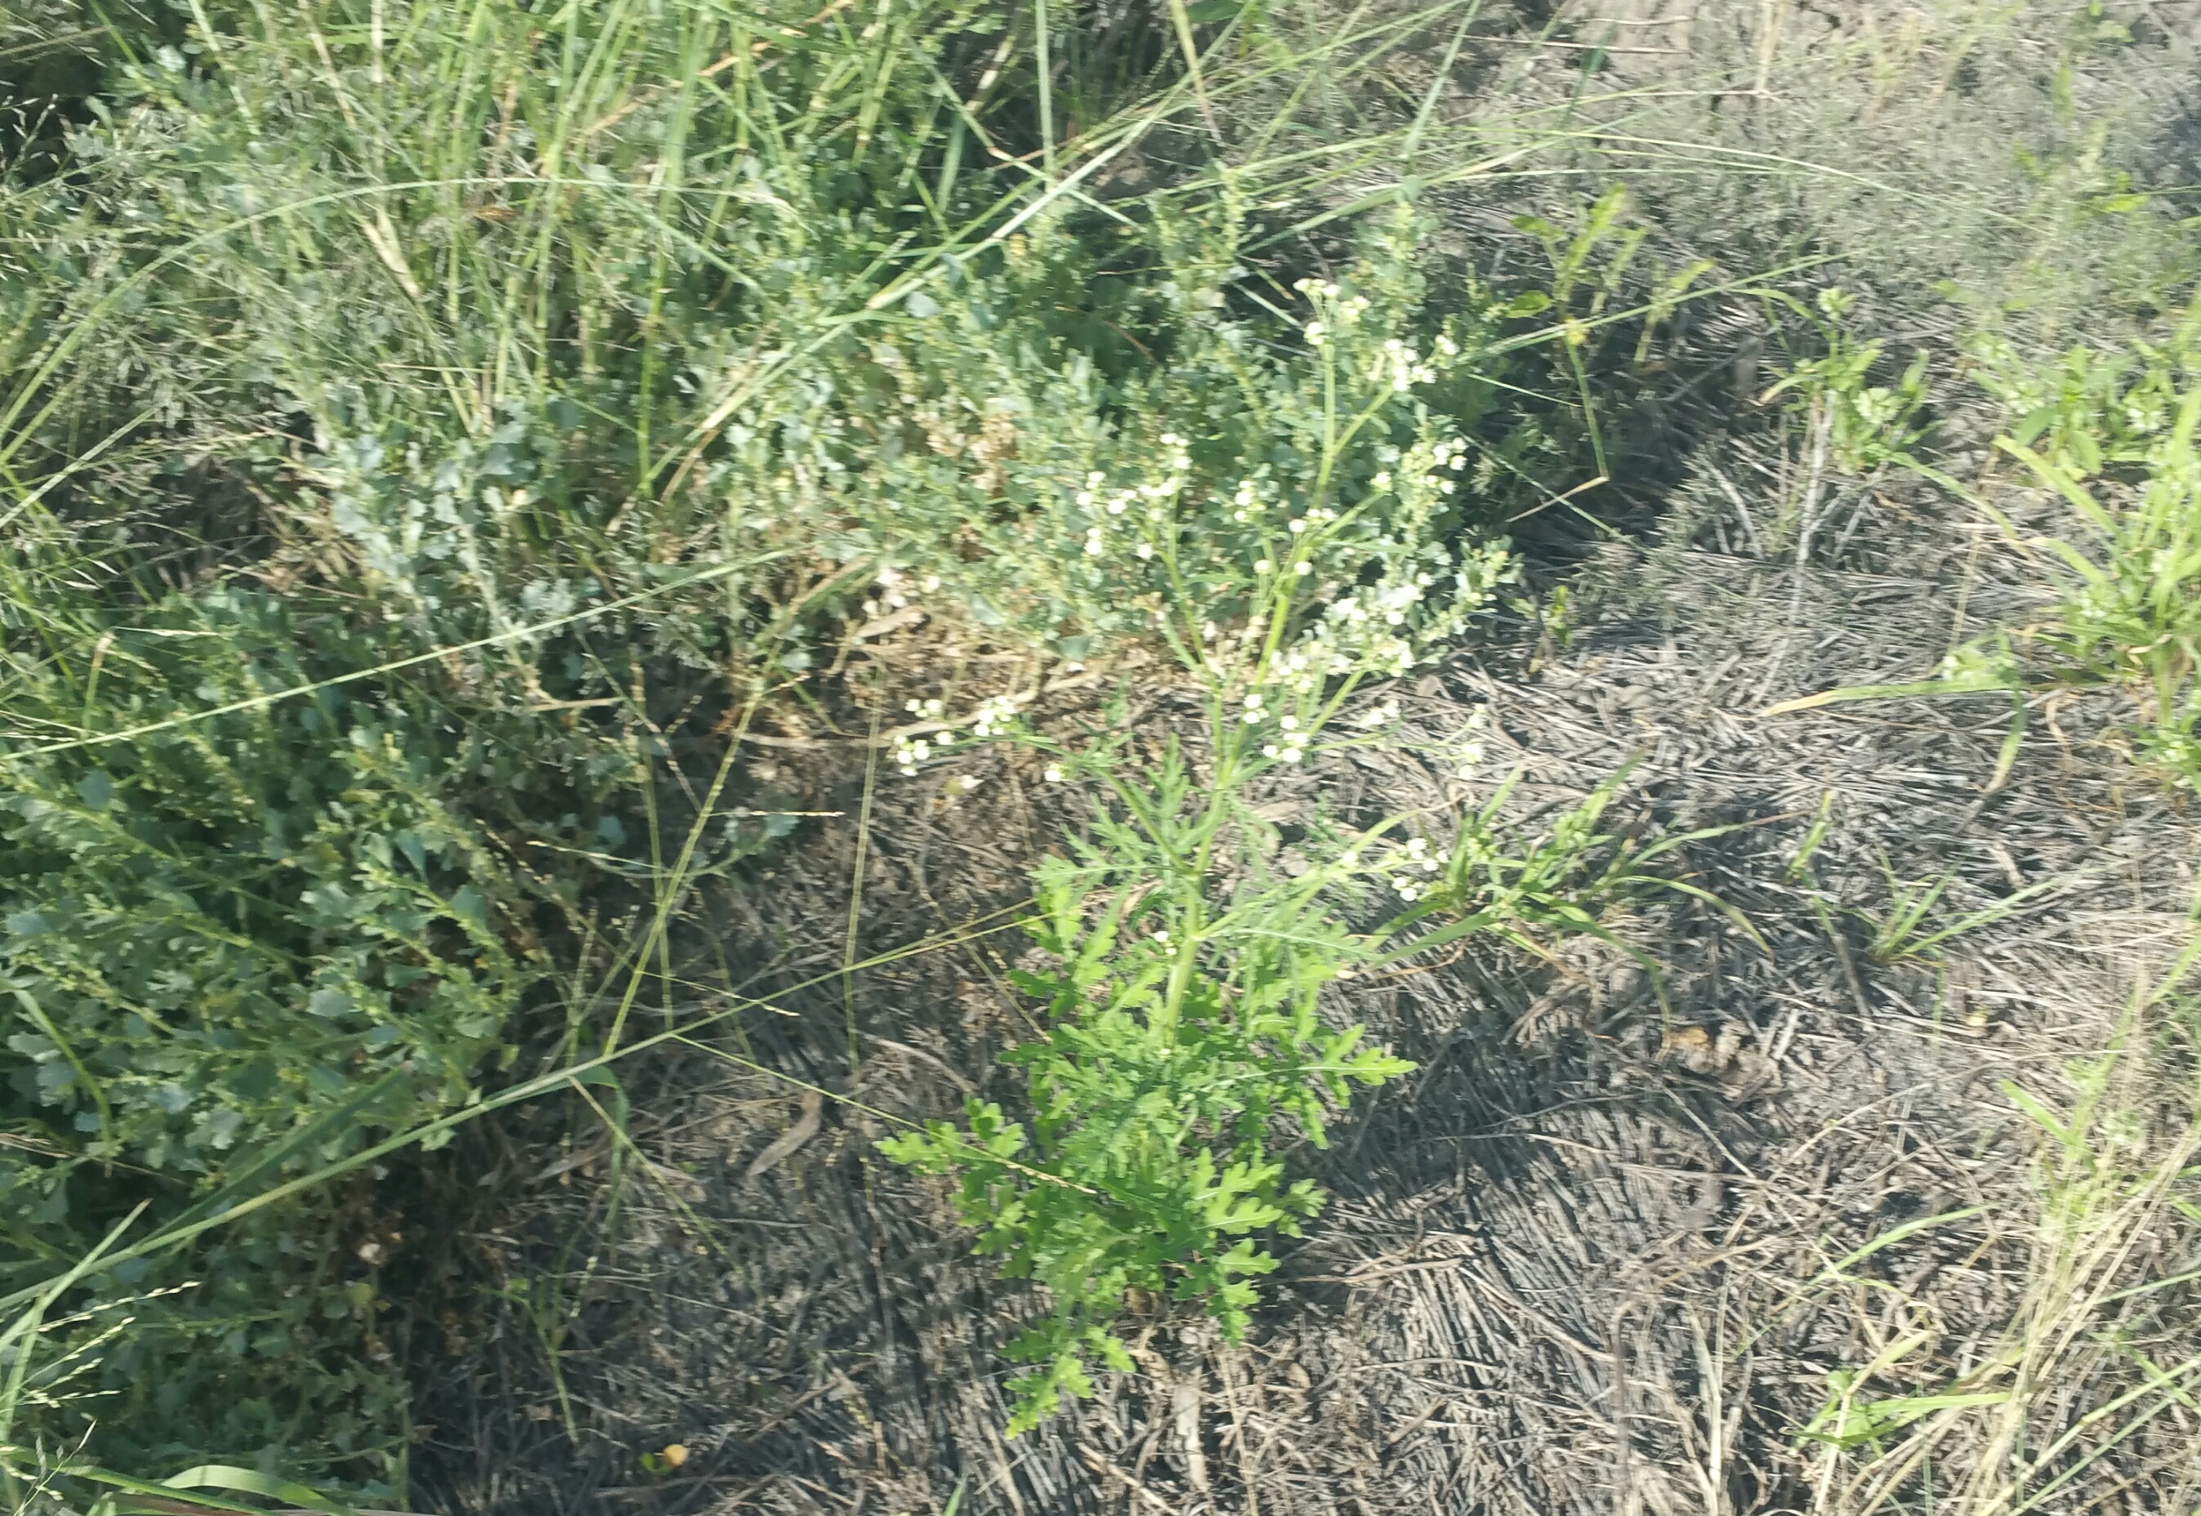
Photo: Don Mackenzie

Parthenium Weed: Adversely affects human and animal health and can cause respiratory problems, severe dermatitis and meat can be tainted, if stock eat the plant within one month of slaughter. Landowners are advised to never touch the plant with bare hands and always use a dust mask if working near the weed for extended periods. Allergic reactions are not always experienced with the first contact with the plant but can develop after a number of exposures. Once a reaction to parthenium weed develops, some individuals may show similar reactions to related plants such as sunflowers. This reaction can be so severe that allergic people can be forced to move away from parthenium weed-infested areas.

North West Regional Best Practice Guide: Parthenium Weed
Botanical Name: Parthenium hysterophorus
Common Name: Parthenium Weed
Priority Weeds Objective – Prevention (Whole of State): This weed is not currently found in some parts of the state, it poses significant biosecurity risks, and prevention of the biosecurity posed by this weed is a reasonably practical objective.

General Biosecurity Duty – Biosecurity Act 2015
A general biosecurity duty applies to all dealings (as defined) with this species. Any person who deals with this species who knows (or ought to know) of any biosecurity risk posed by the plant, a carrier or a dealing , has a duty to ensure the biosecurity risk is prevented, eliminated or minimised, so far as is reasonably practicable.

Regional Recommended Measure
Outcomes to demonstrate compliance with GBD
Prohibited Matter (Part 4, Biosecurity Act, 2015) A person who deals with any biosecurity matter that is Prohibited Matter throughout the State is guilty of an offence.
Mandatory Measure (Division 8, Clause 35, Biosecurity Regulation, 2017)-
Parthenium weed carriers-machinery and equipment:
- This clause applies to the following equipment:
- Grain Harvesters (including the comb or front)
- Comb Trailers (including the comb or front)
- Bins used for holding grain during harvesting operations
- Augers or similar equipment used for moving grain
- Vehicles used for transporting grain harvesters
(f) Vehicles used as support vehicles with grain harvesters and that have been driven in paddocks during harvest operations
(g) Mineral exploration drilling rigs and vehicles used for transporting those rigs
(2) A person must not import into the State from Queensland any equipment to which this clause applies

Liverpool Plains Shire Council Local Control Requirements
- The land is kept free of the plant, and
- Land managers will mitigate the risk of the plant being introduced to their land.

Penalty for not complying with the general biosecurity duty or a direction issued under the Biosecurity Act 2015
The maximum penalty is:
- in the case of an individual—$220,000 and, in the case of a continuing offence, a further penalty of $55,000 for each day the offence continues, or
- in the case of a corporation—$440,000 and, in the case of a continuing offence, a further penalty of $110,000 for each day the offence continues.
The maximum penalty for an offence that is committed negligently is:
- in the case of an individual—$1,100,000 and, in the case of a continuing offence, a further penalty of $137,500 for each day the offence continues, or
- in the case of a corporation—$2,200,000 and, in the case of a continuing offence, a further penalty of $275,000 for each day the offence continues.

PARTHENIUM WEED CONTROL CALANDER
JAN | FEB | MARCH | APRIL | MAY | JUNE | JULY | AUG | SEPT | OCT | NOV | DEC
GROWTH CYCLES
SEEDS GERMINATE |  | SEEDS GERMINATE
FLOWER AND SEED SET |  | FLOWER AND SEED SET
ACTIVE GROWTH |  | ACTIVE GOWTH
INTERGRATED CONTROL TECHNIQUES AND ALTERNATIVES
PHYSICALLY REMOVE PLANTS AND DESTROY BY BURNING ANYTIME THROUGHOUT THE YEAR
HERBICIDE USE
FOLLOW UP ANY REGROWTH AS IT APPEARS AND DESTROY BY PHYSICAL REMOVAL OR SPRAY WITH HERBICIDES
Registered Herbicide Application Rates:
Please refer to the NSW DPI Website NSW WeedWise. https://weeds.dpi.nsw.gov.au for current up to date permits and Registered Chemicals.
Or to NSW Weed Control Handbook 2018 7th Edition for Chemical Options.
Critical Comments:
- Apply when plants are actively growing.
- Consult your LCA Biosecurity Officer- Weeds for application tips.
- Always read and follow the Label instructions and SDS of respective herbicides.
NOTE:
- All Control Techniques involving herbicide use, must comply with the directions on the herbicide label or the conditions set out in a current permit to use a nominated herbicide.
- All chemical control programs must be carried out in accordance with the Pesticides Act 1999 and Pesticide Regulation 2017.
- All Chemical application programs used must be undertaken by or be designed and supervised by an appropriately Certified and Accredited Chemical user.
- Growth patterns and the changes to optimum treatment times will vary with seasonal conditions due to air temperature changes that may coincide with soil and moisture availability.
Disclaimer:
This document has been prepared by the North West Regional Weed Committee and Local Government Control Authorities in good faith and on the basis of best available information. Users of this document must obtain their own advice and conduct their own investigations and assessments of their individual circumstances.

Triclopyr 240 g/L + Picloram 120 g/L (Access™ )
Rate: 1.0 L per 60 L of diesel
Comments: Foliar application. Triclopyr 240 g/L + Picloram 120 g/L (Access™ )
Rate: 1.0 L per 60 L of diesel
Comments: Foliar application.

Linkage to Plans/Strategies  - North West Regional Strategic Weed Management Plan 2017-2022  - NSW Biosecurity Strategy 2013-2021  - NSW Biosecurity Act 2015  - NSW Invasive Species Plan 2018- 2021  - Pesticides Act 1999 and Pesticide Regulation 2017  References  - NSW DPI Website /WeedWise/ NSW Weed Control Handbook 2018 7th Edition | For Further Information contact:  Liverpool Plains Shire Council’s  Authorised Officers –Weeds.  60 Station Street  Quirindi NSW 2343  PH: (02)67461755
Document Last Updated: 07-09-2021

