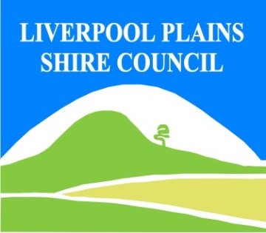
North West Regional Best Practice Guide for: Serrated Tussock
Botanical Name: Nassella trichotoma
Common Name: Serrated Tussock
Priority Weeds Objective – Containment
These weeds are widely distributed in the region. While broad scale elimination is not practicable, minimisation of the biosecurity risk posed by this weed is reasonably practicable.

Serrated Tussock: is highly adapted to a range of environments, seeds prolifically and is difficult and costly to control. Large volumes of seed are spread long distances by wind; allowing new populations to establish over large areas. Serrated tussock is not palatable for livestock and has little feed value. Significant infestations will dramatically reduce carrying capacities. Serrated tussock seeds are also a serious contaminant of hay and grain. Farm machinery such as slashers, vehicles and tractors can readily transport seed to clean areas.
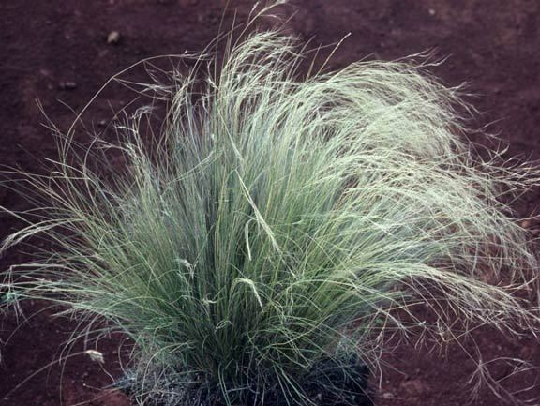
Photo: Auld & Meld

General Biosecurity Duty – Biosecurity Act 2015
A general biosecurity duty applies to all dealings (as defined) with this species. Any person who deals with this species who knows (or ought to know) of any biosecurity risk posed by the plant, a carrier or a dealing , has a duty to ensure the biosecurity risk is prevented, eliminated or minimised, so far as is reasonably practicable.

Liverpool Plains Shire Council Control Requirements

- Reduce the size and density of infested area by physical, mechanical and or chemical control methods, and
- Eliminate or minimise the risk of spread onto neighbouring lands.

Regional Recommended Measure: An exclusion zone is established for all lands in the region, except the core infestation area comprising all Local Government areas land East of the Newell Highway.
Outcomes to demonstrate compliance with GBD
Whole Of region: the plant or parts of the plant are not traded, carried, grown or released into the environment
Within Exclusion Zone: The plant is eradicated from the land and the land is kept free of the plant. Land Managers should prevent spread from their land. Land Managers should mitigate the risk of the plant being introduced to their land
Within Core Infestation: Land managers should reduce impacts from the plant on priority assets.
Mandatory Measure – (Division 8, Clause 33 Biosecurity Regulation 2017)
A person must not import into the State or sell.

Penalty for not complying with the general biosecurity duty or a direction issued under the Biosecurity Act 2015
The maximum penalty is:
- in the case of an individual—$220,000 and, in the case of a continuing offence, a further penalty of $55,000 for each day the offence continues, or
- in the case of a corporation—$440,000 and, in the case of a continuing offence, a further penalty of $110,000 for each day the offence continues.
The maximum penalty for an offence that is committed negligently is:
- in the case of an individual—$1,100,000 and, in the case of a continuing offence, a further penalty of $137,500 for each day the offence continues, or
- in the case of a corporation—$2,200,000 and, in the case of a continuing offence, a further penalty of $275,000 for each day the offence continues.

Serrated Tussock Control Calendar
JAN | FEB | MARCH | APRIL | MAY | JUNE | JULY | AUG | SEPT | OCT | NOV | DEC
GROWTH CYCLES
CAN GERMINATE ANYTIME OF YEAR- MAINLY AUTUMN/WINTER IN FAVOURABLE SEASONAL CONDITIONS
FLOWERING
ACTIVE GROWTH
INTERGRATED CONTROL TECHNIQUES AND ALTERNATIVES
PHYSICALALLY REMOVE PLANTS AND DESTROY THROUGHOUT THE YEAR
OPTIMUM HERBICIDE USE
FOLLOW UP ANY REGROWTH AS IT APPEARS AND DESTROY BY PHYSICAL REMOVAL OR SPRAY WITH HERBICIDES
Registered Herbicide Application Rates:
Please refer to the NSW DPI Website NSW WeedWise. https://weeds.dpi.nsw.gov.au for current up to date permits and Registered Chemicals.
Or to NSW Weed Control Handbook 2018 7th Edition for Chemical Options.
Critical Comments:
- Apply when plants are actively growing.
- Consult your LCA Biosecurity Officer- Weeds for application tips
- Always read and follow the Label instructions and SDS of respective herbicides.
NOTE:
- All Control Techniques involving herbicide use, must comply with the directions on the herbicide label or the conditions set out in a current permit to use a nominated herbicide.
- All chemical control programs must be carried out in accordance with the Pesticides Act 1999 and Pesticide Regulation 2017.
- All Chemical application programs used must be undertaken by or be designed and supervised by an appropriately Certified and Accredited Chemical user.
- Growth patterns and the changes to optimum treatment times will vary with seasonal conditions due to air temperature changes that may coincide with soil and moisture availability.
Disclaimer:
This document has been prepared by the North West Regional Weed Committee and Local Government Control Authorities in good faith and on the basis of best available information. Users of this document must obtain their own advice and conduct their own investigations and assessments of their individual circumstances.

Linkage to Plans/Strategies  - North West Regional Strategic Weed Management Plan 2017-2022  - NSW Biosecurity Strategy 2013-2021  - NSW Biosecurity Act 2015  - NSW Invasive Species Plan 2018- 2021  - Pesticides Act 1999 and Pesticide Regulation 2017  References  NSW DPI Website /WeedWise/ NSW Weed Control Handbook 2018 7th Edition. | For Further Information contact:  Liverpool Plains Shire Council’s  Authorised Officers –Weeds.  60 Station Street  Quirindi NSW 2343  PH: (02)67461755
Document Last Updated: 07-09-2021

