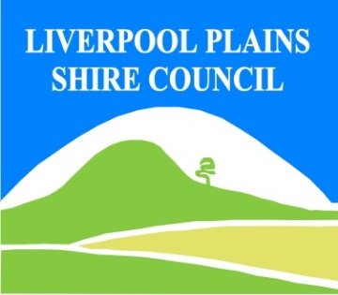
North West Regional Best Practice Guide for: St. John’s wort
Botanical Name: Hypericum perforatum
Common Name: St John’s wort
Priority Weeds Objective - Containment
These weeds are widely distributed in the region. While broad scale elimination is not practicable, minimisation of the biosecurity risk posed by this weed is reasonably practicable.

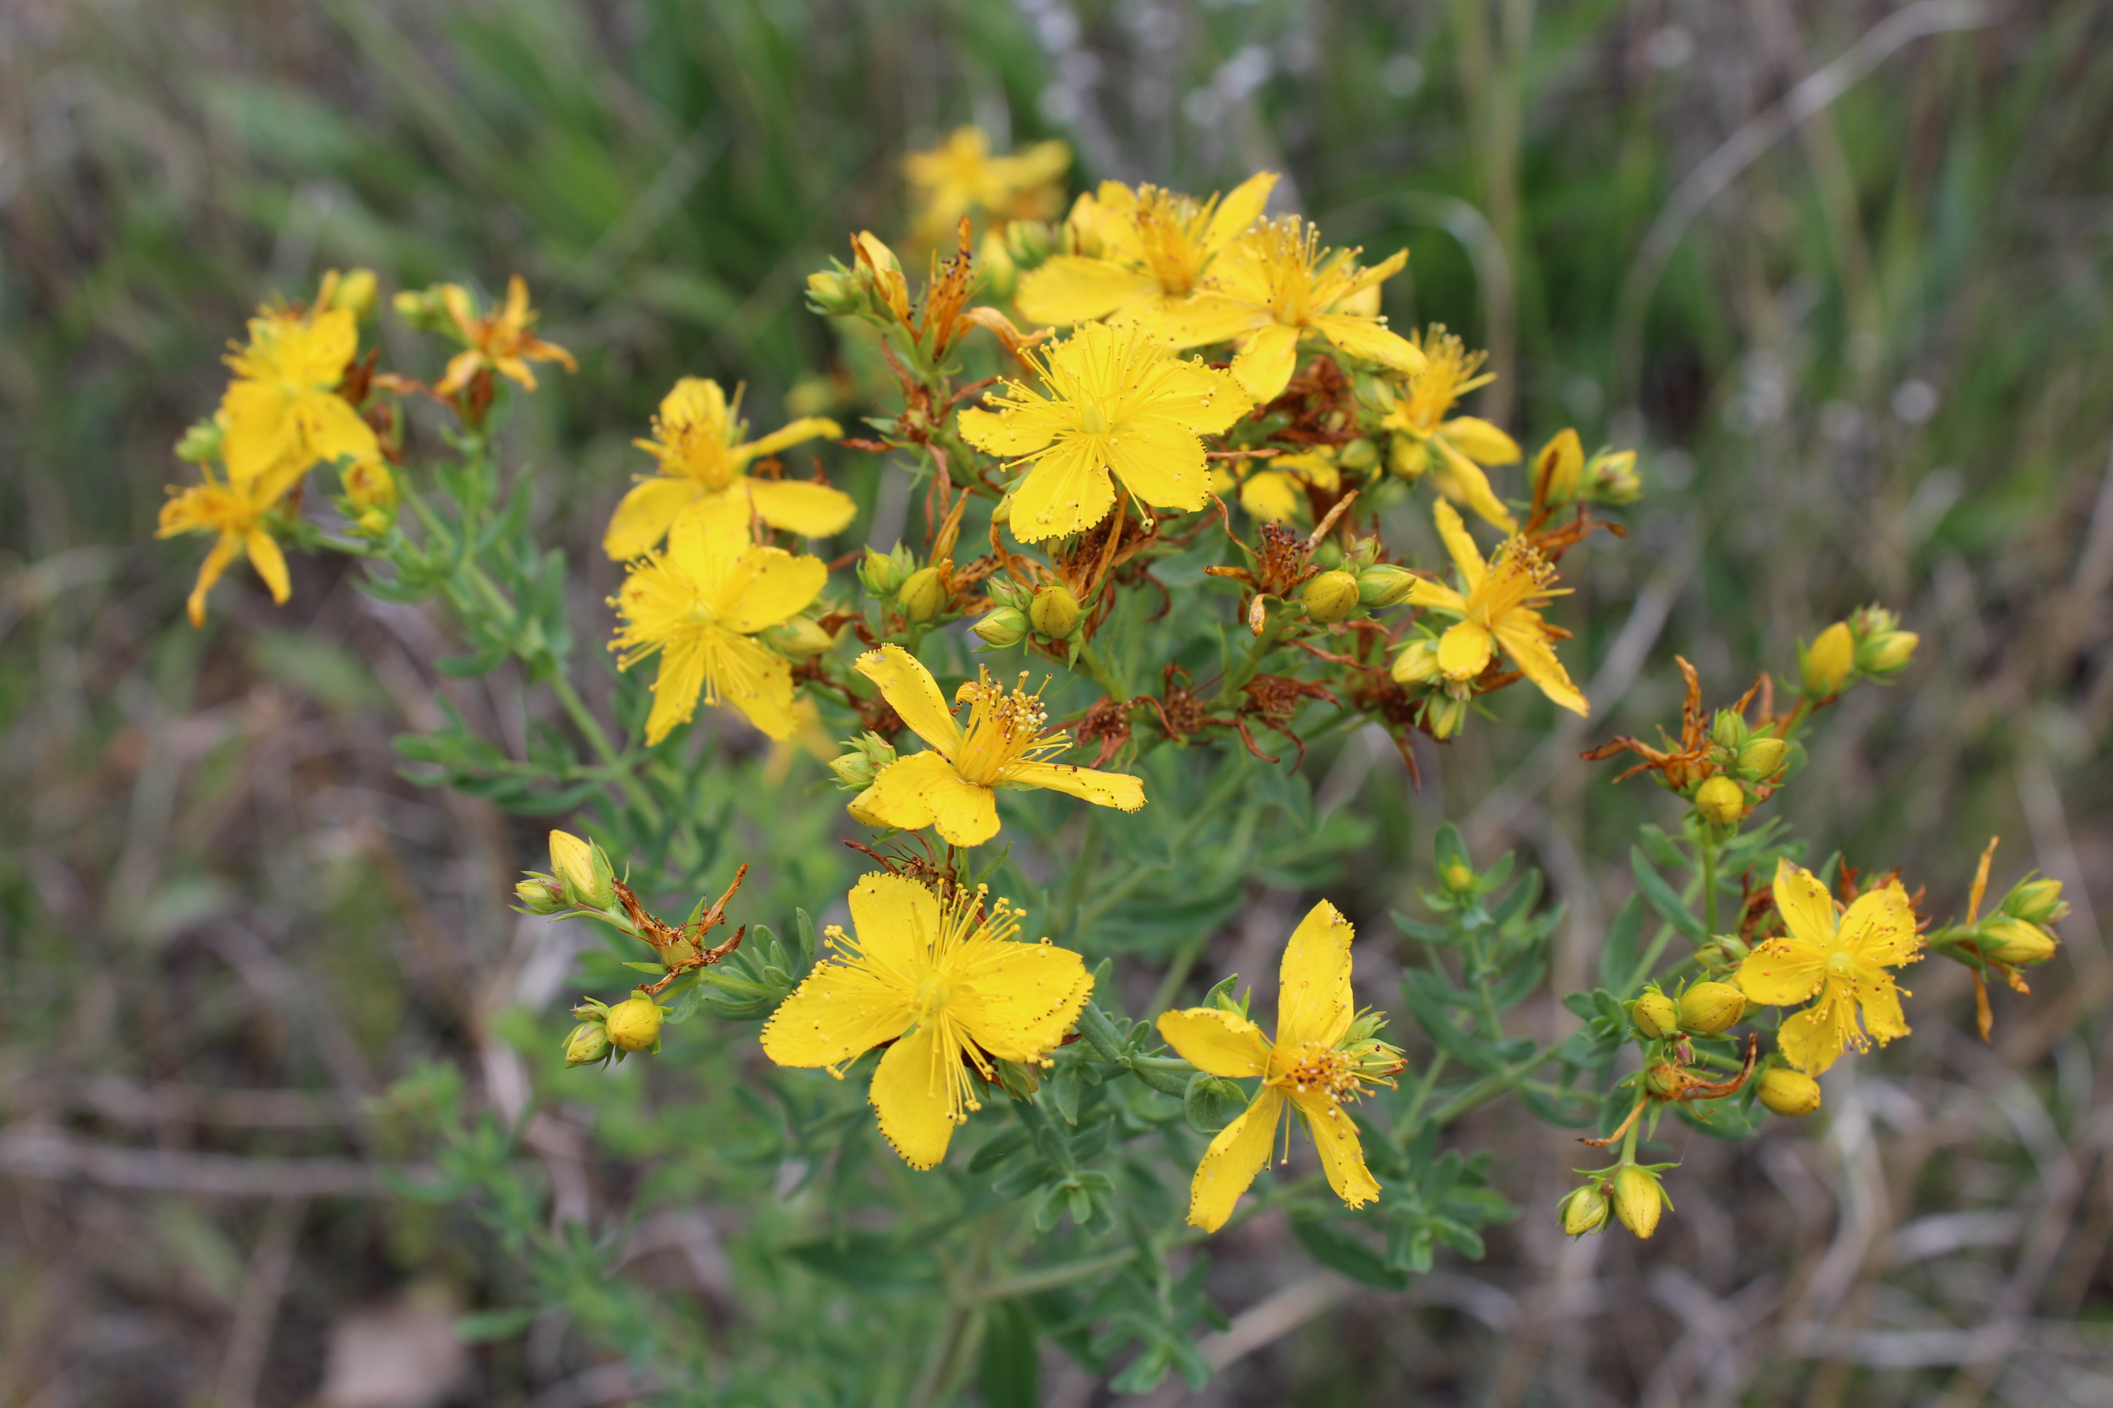
Photo: Mike Whitney
St John’s wort: One St. John’s wort plant can produce 30,000 seeds annually. The sticky seeds are spread primarily by animals and may remain viable in the ground for more than 20 years. It is important that all known infestation sites are regularly monitored. All new plants must be treated before seed set, as everyone left untreated has the potential to produce thousands of new plants.

General Biosecurity Duty – Biosecurity Act 2015
A general biosecurity duty applies to all dealings (as defined) with this species. Any person who deals with this species who knows (or ought to know) of any biosecurity risk posed by the plant, a carrier or a dealing , has a duty to ensure the biosecurity risk is prevented, eliminated or minimised, so far as is reasonably practicable.

Regional Recommended Measure: An exclusion zone is established for all lands in the region, except the core infestation area comprising the Gunnedah Shire Council, Gywdir Shire Council, Liverpool Plains Shire Council and Tamworth Regional Council.
Outcomes to demonstrate compliance with GBD
Whole Of region: the plant or parts of the plant are not traded, carried, grown or released into the environment
Within Core Infestation: Land managers should reduce impacts from the plant on priority assets.
Liverpool Plains Shire Local Control Requirements
Core infestation area within LPSC
- Reduce the size and density of infested area by physical, mechanical and or chemical control methods, and
- Eliminate or minimise the risk of spread onto neighbouring lands.
Exclusion zone within LPSC
- The land is kept free of the plant, and
- Land managers will mitigate the risk of the plant being introduced to their land.
Note: Information showing these Zones within Liverpool Plains Shire Council area please refer to Map attached to this Weed Management Plan

Penalty for not complying with the general biosecurity duty or a direction issued under the Biosecurity Act 2015
The maximum penalty is:
- in the case of an individual—$220,000 and, in the case of a continuing offence, a further penalty of $55,000 for each day the offence continues, or
- in the case of a corporation—$440,000 and, in the case of a continuing offence, a further penalty of $110,000 for each day the offence continues.
The maximum penalty for an offence that is committed negligently is:
- in the case of an individual—$1,100,000 and, in the case of a continuing offence, a further penalty of $137,500 for each day the offence continues, or
- in the case of a corporation—$2,200,000 and, in the case of a continuing offence, a further penalty of $275,000 for each day the offence continues.

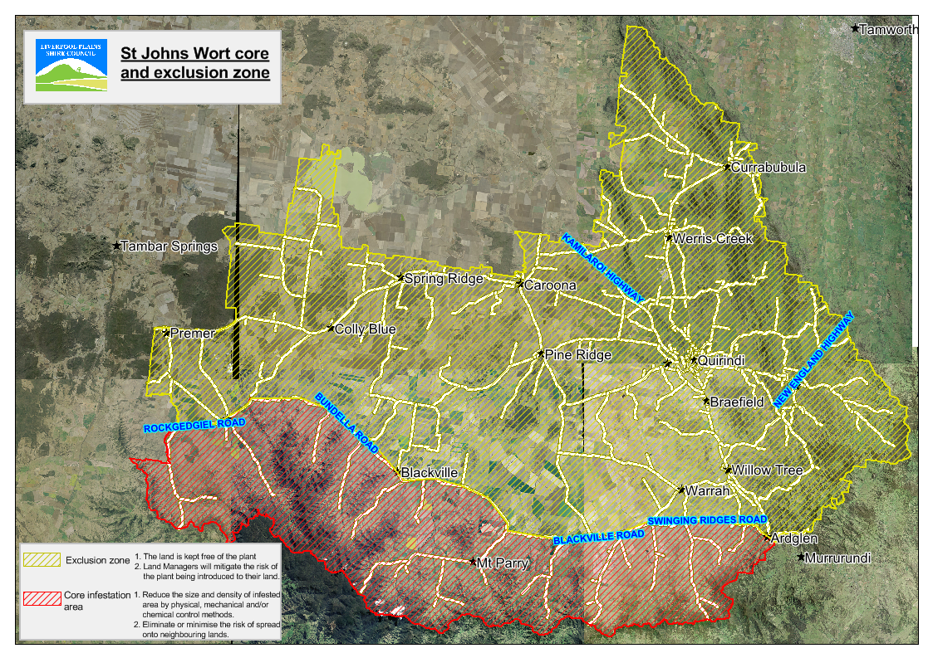
Linkage to Plans/Strategies  - North West Regional Strategic Weed Management Plan 2017-2022  - NSW Biosecurity Strategy 2013-2021  - NSW Biosecurity Act 2015  - NSW Invasive Species Plan 2018- 2021  - Pesticides Act 1999 and Pesticide Regulation 2017  References  - NSW DPI Website /WeedWise/ NSW Weed Control Handbook 2018 7th Edition. | For Further Information contact:  Liverpool Plains Shire Council’s  Authorised Officers (Weeds)  60 Station Street  Quirindi NSW 2343  PH: (02)67461755

St John’s wort Control Calendar
APRIL | MAY | JUNE | JULY | AUGUST | SEPT | OCT | NOV | DEC | JAN | FEB | MAR
GROWTH CYCLES-
GERMINATION |  | GERM/SEEDLING |  | UPRIGHT GROWTH |  | FLOWERING | SENESCENT
PERENNIAL GROWTH AFTER GOOD RAINS |  |  | UPRIGHT GROWTH |  | FLOWERING |  | SENESCENT

INTERGRATED CONTROL TECHNIQUES AND ALTERNATIVES
 | HIGH STOCKING RATES INTENSIVE GRAZING |  |  | HERBICIDE OPTIMUM
PASTURE SOWING/  ESTABLISHMENT/MANAGEMENT |  |  |  |  | PASTURE SOWING/  ESTABLISHMENT/MANAGEMENT
 | HEAVY GRAZING MAY REDUCE FLOWERING & POTENTIAL SEED SET
Note: Managed heavy grazing and /or slashing will not kill St Johns wort
Control Methods/Techniques: An integrated control program offers the most effective control outcome. Combinations of the following methods can be effective.
Manual/Mechanical Physically and carefully remove and burn mature flower heads with viable seed. Isolated annual plants with a single stalk can be destroyed by removing them. All root material must be completely removed in the process or the plants will re-generate.
Chemical: There are a number of Herbicides registered for use to Spot spray and boom spray St John’s wort.
Cultural/Biological: The use of perennial pastures and grazing management, together with the presence of biological control agents may offer some control.
Registered Herbicide Application Rates:
Please refer to the NSW DPI Website NSW WeedWise. https://weeds.dpi.nsw.gov.au for current up to date permits and Registered Chemicals.
Or to NSW Weed Control Handbook 2018 7th Edition for Chemical Options.

Critical Comments:-
- Apply to actively growing plants.
- Consult your LCA Biosecurity Officer- Weeds for application tips.
- Always read and follow the Label instructions and SDS of respective herbicides.
NOTE:
- All Control Techniques involving herbicide use, must comply with the directions on the herbicide label or the conditions set out in a current permit to use a nominated herbicide.
- All chemical control programs must be carried out in accordance with the Pesticides Act 1999 and Pesticide Regulation 2017.
- All Chemical application programs used must be undertaken by or be designed and supervised by an appropriately Certified and Accredited Chemical user.
- Growth patterns and changes to optimum treatment times will vary with seasonal conditions due to rain events and air temperature changes, that may coincide with soil moisture availability.

Disclaimer:
This document has been prepared by the North West Regional Weed Committee and Local Government Control Authorities in good faith and on the basis of best available information. Users of this document must obtain their own specific advice and conduct their own investigations and assessments of their individual circumstances.

Document Last Updated: 07-09-2021

