

**North West Regional Best Practice Guide for**: **Sweet Briar**

**Botanical Name:** Rosa rubiginosa

**Common Names:** Sweet Briar/Briar

**North West Regional Priority Weeds Objective** - Asset Protection

These weeds are widely distributed in the region. Their spread should be minimised to protect priority assets.

**Sweet Briar:** was introduced into Australiaas a garden plant at the time of first European settlement. Sweet briar is an erect prickly shrub similar to the cultivated rose, with cane like branches covered in thorns. Fresh growth commences from early spring to summer. The fruits (Rose Hips) are rounded and orange/red in colour and mature during late summer. The bushes grow to two metres in height and can become an impenetrable thicket, hindering grazing stock. In turn these areas provide and produce less productive pasture.

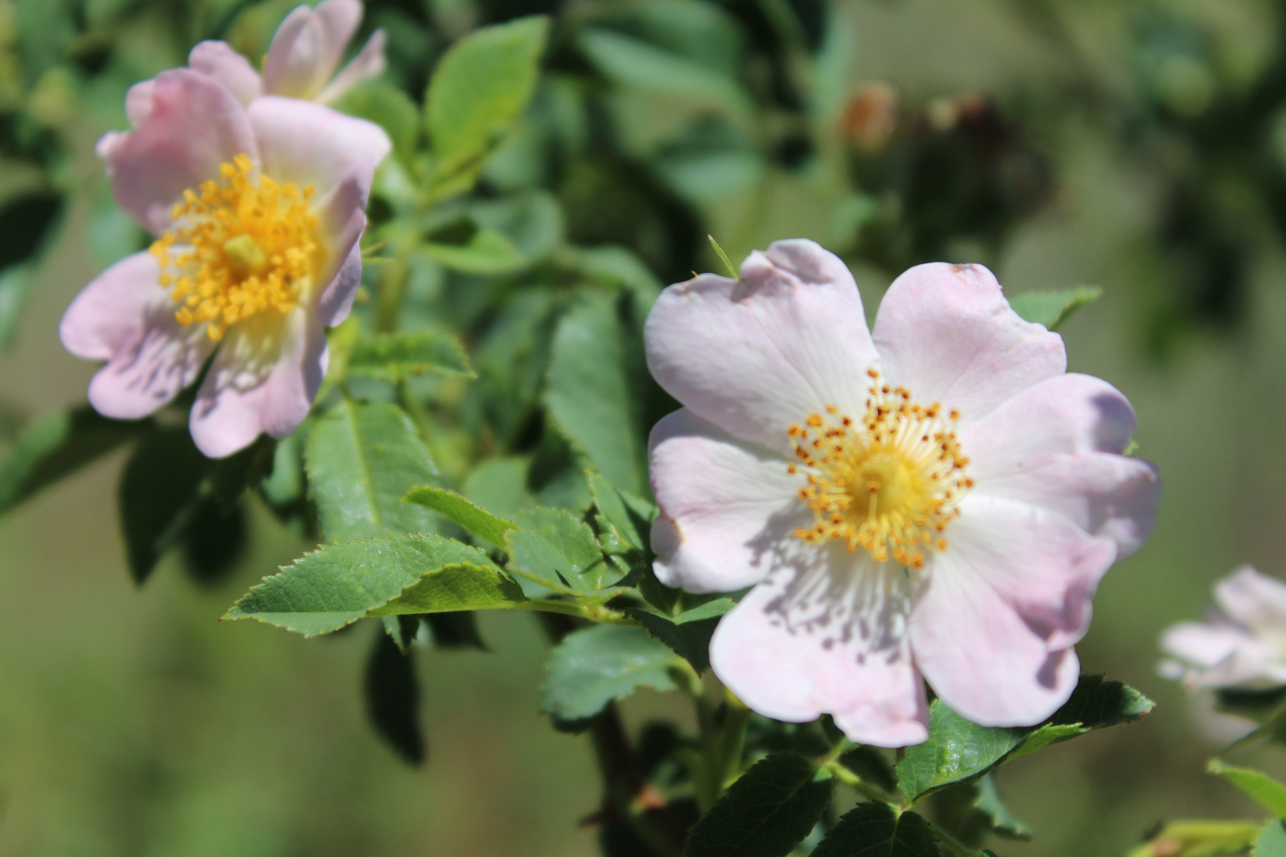

Photo: Mike Whitney

**General Biosecurity Duty – *Biosecurity Act 2015***  
*A* ***general biosecurity duty*** *applies to all dealings (as defined) with this species. Any person who deals with this species who knows (or ought to know) of any biosecurity risk posed by the plant, a carrier or a dealing , has a duty to ensure the biosecurity risk is prevented, eliminated or minimised, so far as is reasonably practicable.*

**Liverpool Plains Shire Local Control Requirements**

1. Reduce the size and density of infested area by physical, mechanical and or chemical control methods, and
2. Eliminate or minimise the risk of spread onto neighbouring lands.

**Regional Recommended Measure**:

**Outcomes to demonstrate compliance with GBD**

* Plant should not be bought, sold, propagated, grown, knowingly distributed, carried or released into the environment.
* Land Managers should mitigate the risk of new weeds being introduced to their land.
* Land Managers should prevent spread from their land.

##### Penalty for not complying with the general biosecurity duty or a direction issued under the *Biosecurity Act 2015*

The maximum penalty is:

* in the case of an individual—$220,000 and, in the case of a continuing offence, a further penalty of $55,000 for each day the offence continues, or
* in the case of a corporation—$440,000 and, in the case of a continuing offence, a further penalty of $110,000 for each day the offence continues.

The maximum penalty for an offence that is committed negligently is:

* in the case of an individual—$1,100,000 and, in the case of a continuing offence, a further penalty of $137,500 for each day the offence continues, or
* in the case of a corporation—$2,200,000 and, in the case of a continuing offence, a further penalty of $275,000 for each day the offence continues.

**Sweet Briar Control Calendar**

|  |  |  |  |  |  |  |  |  |  |  |  |
| --- | --- | --- | --- | --- | --- | --- | --- | --- | --- | --- | --- |
| **JULY** | **AUG** | **SEPT** | **OCT** | **NOV** | **DEC** | **JAN** | **FEB** | **MAR** | **APRIL** | **MAY** | **JUNE** |

**GROWTH CYCLES-**

|  |  |
| --- | --- |
| **GERMINATION** | |
| **PERENNIAL ROOT SPREAD** | | |
| **ACTIVE FOLIAGE GROWTH** | |

**INTERGRATED CONTROL TECHNIQUES AND ALTERNATIVES**

|  |  |
| --- | --- |
| **HERBICIDE** | |
| **MECHANICAL METHODS** | | | | |
| **FOLLOW UP TREATMENT** |
| **INTENSIVE GRAZING BY GOATS** | |

**Registered Herbicide Application Rates:**

Please refer to theNSW DPI Website NSW WeedWise.<https://weeds.dpi.nsw.gov.au> for current up to date permits and Registered Chemicals.

Or to NSW Weed Control Handbook 2018 7th Edition for Chemical Options.

**Critical Comments:**

* Apply when bushes have good leaf growth and cover with no leaf fall.
* Consult your LCA Biosecurity Officer- Weeds for application tips
* Always read and follow the Label instructions and SDS of respective herbicides.

**NOTE:**

1. All Control Techniques involving herbicide use, must comply with the directions on the herbicide label or the conditions set out in a current permit to use a nominated herbicide.
2. All chemical control programs must be carried out in accordance with the *Pesticides Act 1999* and Pesticide Regulation 2017.
3. All Chemical application programs used must be undertaken by or be designed and supervised by an appropriately Certified and Accredited Chemical user.
4. Growth patterns and the changes to optimum treatment times will vary with seasonal conditions due to air temperature changes that may coincide with soil and moisture availability.

**Disclaimer:**

This document has been prepared by the North West Regional Weed Committee and Local Government Control Authorities in good faith and on the basis of best available information. Users of this document must obtain their own specific advice and conduct their own investigations and assessments of their individual circumstances.

|  |  |
| --- | --- |
| **Linkage to Plans/Strategies**   * North West Regional Strategic Weed Management Plan 2017-2022 * NSW Biosecurity Strategy 2013-2021 * NSW Biosecurity Act 2015 * NSW Invasive Species Plan 2018- 2021 * *Pesticides Act 1999* and Pesticide Regulation 2017   **References**   * *NSW DPI Website /WeedWise/ NSW Weed Control Handbook 2018 7th Edition.* | **For Further Information contact:**  Liverpool Plains Shire Council’s  Authorised Officers (Weeds)  60 Station Street  Quirindi NSW 2343  PH: (02)67461755 |

Document Last Updated: 07-09-2021