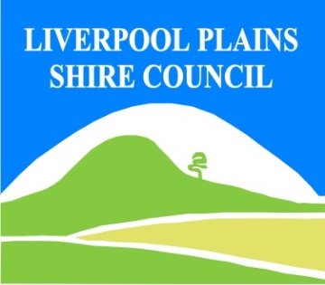
North West Regional Best Practice Guide for: Water Hyacinth
Botanical Name: Eichhornia Crassipes
Common Names: Water Hyacinth
Priority Weeds Objective - Containment
These weeds are widely distributed in the region. While broad scale elimination is not practicable, minimisation of the biosecurity risk posed by this weed is reasonably practicable.

Water Hyacinth is considered to be the world’s worst aquatic weed. It infests rivers, dams, lakes and irrigation channels on every continent except Antarctica.
It is difficult to control in all freshwater aquatic environments. It is essential that any new infestations be
Controlled as soon as possible.

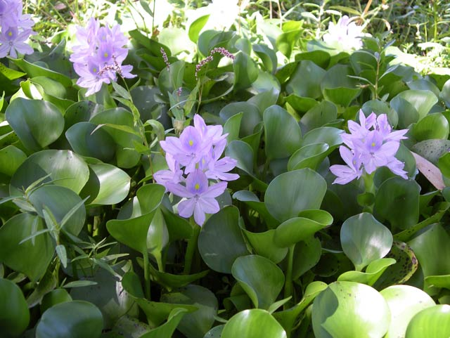
Photo: Ian Schwartz

General Biosecurity Duty – Biosecurity Act 2015
A general biosecurity duty applies to all dealings (as defined) with this species. Any person who deals with this species who knows (or ought to know) of any biosecurity risk posed by the plant, a carrier or a dealing , has a duty to ensure the biosecurity risk is prevented, eliminated or minimised, so far as is reasonably practicable.

Regional Recommended Measure: An exclusion zone is established for all lands in the region, except the core infestation area comprising lands within the Moree Plains Shire Council
Outcomes to demonstrate compliance with GBD
Whole of Region: The plant or parts of the plant are not traded, carried, grown or released into the environment.
Within Exclusion Zone: the plant is eradicated from the land and the land is kept free of the plant
Within Core Infestation: Land managers should reduce impacts from the plant on priority assets.
Mandatory Measure: A person must not import into the State or sell

Moree Plains Shire Local Control Requirements
Core infestation area within MPSC
- Reduce the size and density of infested area by physical, mechanical and or chemical control methods, and
- Eliminate or minimise the risk of spread onto neighbouring lands.
Exclusion zone within MPSC
- The land is kept free of the plant, and
- Land managers will mitigate the risk of the plant being introduced to their land.
Note: Information showing these Zones within Moree Plains Shire Council area please refer to Map attached to this Weed Management Plan

Penalty for not complying with the general biosecurity duty or a direction issued under the Biosecurity Act 2015
The maximum penalty is:
- in the case of an individual—$220,000 and, in the case of a continuing offence, a further penalty of $55,000 for each day the offence continues, or
- in the case of a corporation—$440,000 and, in the case of a continuing offence, a further penalty of $110,000 for each day the offence continues.
The maximum penalty for an offence that is committed negligently is:
- in the case of an individual—$1,100,000 and, in the case of a continuing offence, a further penalty of $137,500 for each day the offence continues, or
- in the case of a corporation—$2,200,000 and, in the case of a continuing offence, a further penalty of $275,000 for each day the offence continues.

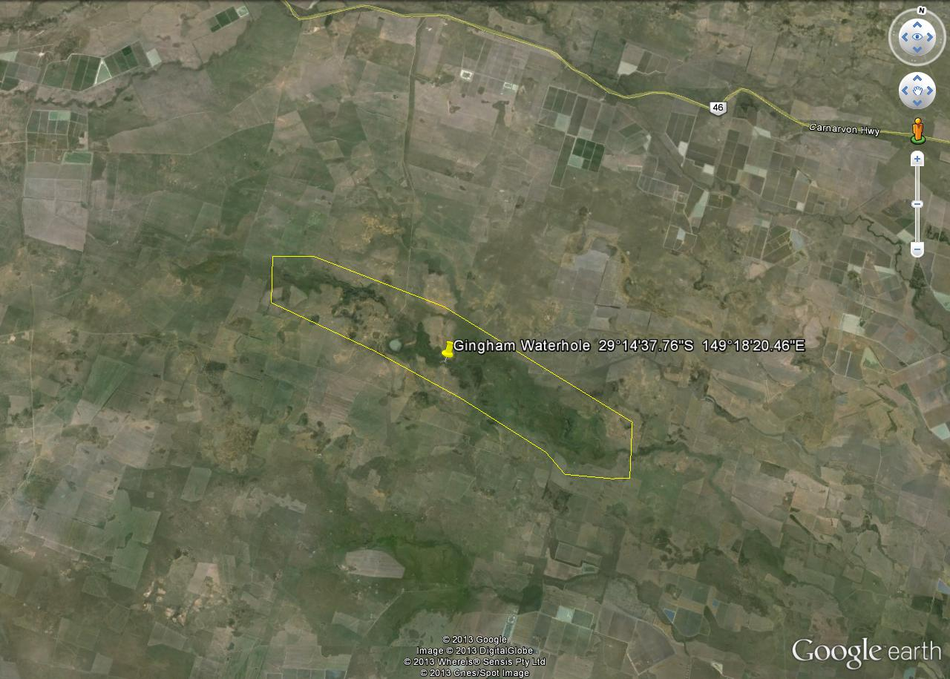
Map of Core Infestation Area, Gingham Watercourse, Moree Plains Shire Council

Linkage to Plans/Strategies  - North West Regional Strategic Weed management Plan 2017-2022  - NSW Biosecurity Strategy 2013-2021  - NSW Biosecurity Act 2015  - Pesticides Act 1999 and Pesticide Regulation 2017  References  - NSW DPI Website /Weedwise/ NSW Weed Control Handbook 2018 7th Edition | For Further Information contact:  Moree Plains Shire Council’s  Authorised Officers (Weeds)  Level 2  30 Heber Street  Moree NSW 2400  PH: (02)67573222

Water Hyacinth Control Calendar
JAN | FEB | MAR | APR | MAY | JUN | JUL | AUG | SEPT | OCT | NOV | DEC
GROWTH CYCLES-
GERMINATION | WINTER DORMANCY |  | GERMINATION
FLOWERING & SEED SET |  |  |  | FLOWERING & SEED SET

INTERGRATED CONTROL TECHNIQUES AND ALTERNATIVES

 | HERBICIDE OPTIMUM |  | HERBICIDE OPTIMUM
MECHANICAL
Control Methods/Techniques: An integrated control program offers the most effective control outcome. Combinations of the following methods can be effective.
Manual/Mechanical: Removing plants from small areas of water such as farm dams and drains is an effective form of controlling Water hyacinth , but only when the rate of removal is faster than the rate of growth. Mechanical harvesters can be used.
Chemical: There are a number of Herbicides registered for use to Spot spray and boom spray Water hyacinth.
Cultural/Biological: As part of a control program, nutrient run-off into infested waterways should be minimised. Drainage or reduction of water levels can also reduce the area of Water hyacinth plants, but it is important to note that seeds will remain viable in the soil and will germinate when the area refills with water.
Registered Herbicide Application Rates:
Please refer to the NSW DPI Website NSW WeedWise. https://weeds.dpi.nsw.gov.au for current up to date permits and Registered Chemicals.
Or to NSW Weed Control Handbook 2018 7th Edition for Chemical Options.

Critical Comments:
- Apply to actively growing plants.
- Consult your LCA Biosecurity Officer- Weeds for application tips.
- Always read and follow the Label instructions and SDS of respective herbicides.
NOTE:
- All Control Techniques involving herbicide use, must comply with the directions on the herbicide label or the conditions set out in a current permit to use a nominated herbicide.
- All chemical control programs must be carried out in accordance with the Pesticides Act 1999 and Pesticide Regulation 2017.
- All Chemical application programs used must be undertaken by or be designed and supervised by an appropriately Certified and Accredited Chemical user.
- Growth patterns and changes to optimum treatment times will vary with seasonal conditions due to rain events and air temperature changes that may coincide with soil moisture availability.

Disclaimer:
This document has been prepared by the North West Regional Weed Committee and Local Government Control Authorities in good faith and on the basis of best available information. Users of this document must obtain their own specific advice and conduct their own investigations and assessments of their individual circumstances.

Document Last Updated: 07-09-2021

