LIVERPOOL PLAINS SHIRE COUNCIL
Growth Management Strategy
Draft Addendum

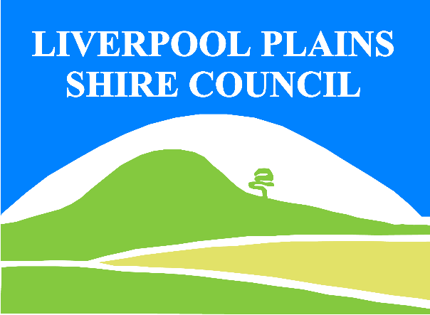
Draft Strategy Outline
In 2017 the Liverpool Plains Shire Council called for Expressions of Interest from the community interested in changing the planning provisions applying to their lands.
Council received submissions for 10 properties near Currabubula, with property owners requesting rezoning from RU1 Primary Production to R5 Large Lot Residential and a reduction in the Minimum Lot Size. The reduction in Minimum Lot Size would result in a dwelling entitlement for 8 of the sites.
Council chose to enact this request in 2019 by resolving to amend the Liverpool Plains Local Environmental Plan 2011 to implement changes that were requested by the community. The changes sought via the Planning Proposal involved rezoning 10 lots in Currabubula from RU1 Primary Production to RU5 Large Lot Residential and reducing the minimum lot size to 5 ha.
However, this was subsequently rejected by the NSW Department of Planning, Industry & Environment as Council’s adopted the Liverpool Plains Shire Council Growth Management Strategy 2009 does not address the strategic need for the rezoning of land at Currabubula for the purpose of rural residential development. The proposal was considered contrary to the Liverpool Plains Shire Council Growth Management Strategy 2009 and as such inconsistent with the New England North West Regional Plan 2036. NSW Department of Planning, Industry & Environment stated that any changes to existing planning provisions, whether they be zoning, minimum lot size or dwelling opportunities are required to be supported by a strategy.
Council reacted by engaging aa suitably qualified consultant, GHD, to prepare an Addendum to the Liverpool Plains Shire Council Growth Management Strategy 2009. Its’ purpose is to support any future Planning Proposal to rezone land in Currabubula from RU1 Primary Production to RU5 Large Lot Residential and reducing the minimum lot size to enable dwelling permissibility. However, the final Addendum will need to be accompanied by further environmental assessment.
The draft Addendum establishes a set of clear criteria to determine the constraints and opportunities applicable to the rural residential development of 10 sites. The suitability of each site by assess by undertaking the:
- Review of the current planning context and framework,
- Establishment and development of criteria to determine the suitability of the sites for rural residential use,
- Analysis of the opportunities and constraints affecting the proposed changes, and
- Provision of justifications and recommendations based on the findings to support or not support the proposed changes.
The result is a set of Settlement Principles applicable to rural residential development to provide a guide and framework to assist with the determination of future housing on the subject sites.
Prior to adopting the draft Addendum Council wishes to consult with the landowners who may be impacted and the community at large. The full document is available on Council’s website being www.lpsc.nsw.gov.au ,and at Council’s Offices (62 Station Street, Quirindi).
Submissions are requested in writing and can be emailed to lpsc@lpsc.nsw.gov.au. They must be made out to the General Manager and be received by close of business on 11 August 2021.
For further information, a public meeting will be held on Wednesday 21 July 2021 at 6.30pm at Currabubula Hall otherwise please contact Council’s Planning Officers on 67461755.

